

Integrated Acoustic Feature Analysis for Parkinson’s Disease Detection Using Spectrogram and Formant Images with Deep Feature Extraction and Machine Learning Models.

By
Mst. Farhana Akter (ID: 231000322E)
Asmana Yasmin (ID: 231000422E)

Department of Computer Science & Engineering

School of Science, Engineering & Technology

Supervised by

Riad Hossain

Lecturer

In partial fulfillment of the requirement for the degree of Bachelor of Science in Computer Science and Engineering
30th December, 2025

East Delta University

Noman Society, East Nasirabad, Chittagong-4209
Integrated Acoustic Feature Analysis for Parkinson’s Disease Detection Using Spectrogram and Formant Images with Deep Feature Extraction and Machine Learning Models.
This thesis is submitted in partial fulfillment of the requirement for the degree of Bachelor of Science in Computer Science & Engineering.



By
Mst. Farhana Akter (ID: 231000322E)
Asmana Yasmin (ID: 231000422E)

Supervised by
Riad Hossain
Lecturer of CSE

Department of Computer Science & Engineering
School of Science, Engineering & Technology
East Delta University Noman Society, East Nasirabad, Chittagong-4209

The undergraduate thesis titled Multimodal Acoustic Feature Analysis for Parkinson’s Detection Using Spectrograms and Formants with Hybrid Machine Learning submitted by Mst. Farhana Akter, ID: 231000322E and Asmana Yasmin, ID: 231000422E has been accepted as satisfactory in fulfilment of the requirement for the degree of Bachelor of Science (B.Sc.) in Computer Science and Engineering (CSE) to be awarded by East Delta University.

Board of Examiners

Golam Moktader Daiyan Member

Associate Professor

School of Science, Engineering and Technology

East Delta University

Mohammed Morshed Rana Member

Lecturer

School of Science, Engineering and Technology

East Delta University

Sourav Adhikary Member

Lecturer

School of Science, Engineering and Technology

East Delta University

Riad Hossain Supervisor
Lecturer

School of Science, Engineering and Technology

East Delta University

Declaration

It is hereby declared that the work contained in this thesis is original. The information derived from the literature or work has been duly acknowledged and presented in the reference section. No part of this thesis has been submitted elsewhere for the degree, diploma or other similar title of recognition.

Date: 30th December, 2025

_____________________

Mst. Farhana Akter

ID: 231000322E

_____________________

Asmana Yasmin

ID: 231000422E

ACKNOWLEDGEMENT

We would like to express our sincere gratitude and indebtedness to our project supervisor, Riad Hossain, for his valuable time, guidance, encouragement, support, and cooperation throughout the duration of our project.

We sincerely thank the Department of Computer Science and Engineering, East Delta University, for allowing us to enhance our technical skills while undergoing this project. This project provided us with a practical understanding of various parameters involved in the development of an application, including the working and integration of the front end and back end to create a fully functional application.
Finally, we would like to extend our gratitude to prof Dr. Ashad Kabir, Charles Sturt University (Australia), for his constant support and encouragement.

TABLE OF CONTENTS
Declaration IV
Acknowledgement V
Table of Contents VI
List of Tables IIX
List of Figures X
List of Abbreviation XII
Abstract XII
1 Chapter 1 Introduction 1
1.1 Background Study 2
1.2 Problem Statements 3
1.3 Application 4
1.4 Objectives 5
1.5 Motivation 5
1.6 Thesis Structure 6
2 Chapter 2 Literature Review 7
2.1 Image-Based Parkinson’s Disease Detection 9
2.2 Image Processing for Speech Representations 11
2.3 Deep Learning for Feature Extraction 11
2.4 Machine Learning for Classification 12
3 Chapter 3 Methodology 13
3.1 Dataset Description 13
3.2 Speech Converted to Image Representations 14

3.2.1 Spectrogram Image Generation 14

3.2.2 Formant (F1–F4) Image Generation 16

3.2.2.1 Data Augmentation for Formant Images 17

3.3 Image Preprocessing 19

3.3.1 Spectrogram Image Preprocessing 19

3.3.1.1 Spectrogram Enhancement Operations 19

3.3.1.2 Spectrogram Preprocessing 20

3.3.2 Formant Image Preprocessing 20

3.3.2.1 Preprocessing Steps 21

3.4 Deep Learning Feature Extraction 21

3.4.1 Spectrogram Deep Feature Extraction and Classification 21

3.4.2 Formant-Based Deep Feature Extraction and Classification 23

3.5 CNN and Transformer Architectures 24
3.6 Machine Learning Classifiers on Deep Features 25
3.7 Evaluation Metrics 27
4 Chapter 4 Results and Analysis 29
4.1 Performance Analysis Using Spectrogram-Based Features 29

4.1.1 Confusion Matrix using spetrogram based Feature 30
4.2 Performance Analysis Using Formant-Based Feature 31

4.2.1 Confusion Matrix using Formants based Feature 33
4.3 Comparative Analysis Between Spectrogram and Formant-Based Approaches 34
4.4 ROC Curve Analysis 35
4.5 Comparison with Existing Spectrogram-Based Studies on the PC-GITA Dataset 36
4.6 Discussion 37
5 Chapter 5 Conclusion 38
5.1 Summary of the Study 38
5.2 Strengths of the Proposed Framework 39
5.3 Limitations of the Study 39
5.4 Future Work 40
REFERENCES 41

LIST OF TABLES

Table 1: Comparison Speech feature comparison between PD patients and HC. 3
Table 2: Summary of Parkinson’s voice datasets. 7
Table 3 : Summary of Image-Based Parkinson’s Disease Detection Approaches 9
Table 4. Participant distribution in PC-GITA (before segmentation) [39] 14
Table 5. Data instances before vs. after 10-second splitting 14
Table 6. Spectrogram image dataset size (before vs. after augmentation) 15
Table 7. Formant-image dataset size (before vs. after augmentation) 17
Table 8: Spectrogram preprocessing pipeline and parameters 20
Table 9: Formant image preprocessing pipeline (Python implementation) 21
Table 10: Performance of Different CNN Feature Extractors Using Spectrogram Features 29
Table 11: Performance of Different CNN Feature Extractors Using Formant Features 32
Table 12: Spectrogram vs formant features for speech classification. 35
Table 13: PC-GITA–based comparison of spectrogram methods for PD detection. 36

LIST OF FIGURES

Figure 3.1 illustrates the overall workflow of the proposed system. 13
Figure 3.2 Spectrogram 15
Figure 3.3 Formants 17
Figure 3.4 ViT-based feature extraction with logistic regression classifier 22
Figure 3.5 DenseNet121 with logistic regression classifier architecture 23
Figure 3.6 Confusion Matrix 27
Figure 3.7 Confusion Matrix Using Spectrogram-Based Features 31
Figure 3.8 Confusion Matrix Using Formants-Based Features 34
Figure 3.9 ROC Curve 35

LIST OF ABBREVIATION

PD | Parkinson’s Disease
HC | Healthy Control
ML | Machine Learning
DL | Deep Learning
CNN | Convolutional Neural Network
ViT | Vision Transformer
LR | Logistic Regression
MFCC | Mel-Frequency Cepstral Coefficients
DDK | Diadochokinetic
SVD | Saarbrücken Voice Database
UCI | University of California, Irvine
F1-score | Harmonic Mean of Precision and Recall

ABSTRACT

Parkinson’s disease (PD) is a rapidly growing neurodegenerative disorder worldwide, with a steady increase in evalence and mortality, particularly in low- and middle-income countries. Early diagnosis of PD remains challenging due to the reliance on specialist-driven clinical assessment and costly neuroimaging techniques, which are often inaccessible in resource-constrained environments. According to World Health Organization estimates, approximately 3,700 people had died from Parkinson’s disease in Bangladesh up to the year 2020, highlighting the growing national burden of the disease and the need for accessible screening solutions. Speech-based analysis has therefore emerged as a promising non-invasive and cost-effective alternative, as vocal impairments frequently appear in the early stages of the disease. This thesis proposes an image-based speech analysis framework for Parkinson’s disease detection using spectrogram and formant (F1–F4) representations of speech signals. Speech recordings from the PC-GITA dataset, consisting of 100 subjects (50 PD and 50 healthy controls), were segmented and transformed into spectrogram and formant images. Image preprocessing and data augmentation were applied to improve robustness and address class imbalance. Deep learning models were employed for feature extraction, followed by classical machine learning classifiers for final prediction. Experimental results demonstrate that spectrogram-based deep features extracted using a Vision Transformer combined with Logistic Regression achieved an accuracy of 99%, while formant-based analysis using the F1+F2+F3 combination with InceptionV3 as the feature extractor and Logistic Regression as the classifier achieved an accuracy of 96.19%. These findings indicate that speech-derived image representations can serve as reliable digital biomarkers for Parkinson’s disease detection, supporting accurate and low-cost screening in real-world clinical and resource-limited settings such as Bangladesh.

Keywords: Parkinson’s Disease, Speech, Spectrogram, Spectrogram, Formant, Deep Learning, Machine learning.

CHAPTER 1

INTRODUCTION
Parkinson’s disease (PD) is a chronic and progressive neurodegenerative disorder that primarily affects the motor system due to the gradual loss of dopamine-producing neurons in the substantia nigra region of the brain [1]. Dopamine plays a critical role in regulating voluntary movement, and its depletion leads to impaired motor control, resulting in classical symptoms such as resting tremor, muscle rigidity, bradykinesia, and postural instability [2]. In addition to motor impairments, Parkinson’s disease is also associated with non-motor symptoms including cognitive decline, depression, sleep disturbances, and speech disorders [3]. The disease was first systematically described in 1817 by James Parkinson in his pioneering work, "An Essay on Shaking Palsy," which established the clinical foundation for Parkinson's disease research and diagnosis [4].
Globally, Parkinson’s disease is recognized as the second most common neurodegenerative disorder after Alzheimer’s disease, and its prevalence has increased substantially over the past decades due to population aging [5]. It is estimated that more than ten million people worldwide are currently living with Parkinson’s disease, and this number is projected to rise significantly in the future [6]. In developing countries such as Bangladesh, Parkinson’s disease poses a growing but under-recognized public health challenge. Limited access to neurological specialists, lack of large-scale epidemiological studies, and inadequate diagnostic infrastructure contribute to delayed or missed diagnosis [7]. Hospital-based clinical studies in Bangladesh indicate that motor slowness, tremor, and voice-related impairments are among the most frequently observed symptoms in Parkinson’s patients, suggesting that speech dysfunction is a prominent clinical feature in the local population [8].

Recent epidemiological evidence further highlights the increasing burden of Parkinson’s disease in Bangladesh. The annual mortality rate from Parkinson’s disease has increased by 46.6% since 1990, with an average annual growth rate of approximately 2%, indicating a steady rise in disease-related mortality [77]. The disease is reported to be more prevalent among men over the age of 80; however, mortality within this group remains relatively lower. In contrast, the highest mortality rate among women is observed in the 75–79 years age group [77]. According to World Health Organization estimates, approximately 3,700 people had died from Parkinson’s disease in Bangladesh up to the year 2020, highlighting the growing national burden of the disease and the need for accessible screening solutions. Speech-based analysis has therefore emerged as a promising non-invasive and cost-effective alternative, as vocal impairments frequently appear in the early stages of the disease.
, accounting for approximately 0.53% of all deaths in the country [87]. These findings emphasize the growing impact of Parkinson’s disease in Bangladesh and underline the urgent need for early, accessible, and cost-effective diagnostic solutions.
At present, the diagnosis of Parkinson’s disease is primarily based on clinical evaluation performed by experienced neurologists [9]. Neuroimaging techniques such as Magnetic Resonance Imaging (MRI) and Dopamine Transporter imaging (DaTscan) are sometimes used to support diagnosis and differentiate Parkinson’s disease from other movement disorders [10]. However, these techniques are expensive, require advanced medical facilities, and are not widely available in low-resource settings. In countries like Bangladesh, the high cost and limited availability of MRI and DaTscan significantly restrict their use for routine screening and early diagnosis [11].
In recent years, speech and voice analysis has emerged as a promising, non-invasive, and cost-effective alternative for Parkinson’s disease detection [12]. Speech production is a complex neuromuscular process that is highly sensitive to dopamine deficiency, and vocal impairments such as reduced loudness, monotone pitch, hoarseness, imprecise articulation, and abnormal speech rhythm (hypokinetic dysarthria) often appear in the early stages of the disease. sometimes before severe motor symptoms [13, 14]. A substantial body of research has demonstrated the effectiveness of voice-based Parkinson’s disease detection across multiple languages, including English [15, 16, 17], Spanish [18], Mandarin Chinese [19], Portuguese [20], Turkish [21], Czech [22], and Italian [23]. These studies report that acoustic features derived from speech signals—such as spectral patterns, temporal dynamics, and deep-learned embeddings—can effectively differentiate Parkinson’s patients from healthy individuals, often achieving high classification accuracy [15, 17, 20].
In this study, Parkinson’s disease detection is implemented using a two-step pipeline combining deep learning and machine learning techniques, which has not been explored in previous studies. While earlier research has focused on traditional voice analysis methods, extracting conventional acoustic features for classification, no prior work has utilized an integrated deep feature extraction pipeline for spectrogram-based Parkinson’s disease detection. In our approach, speech signals are analyzed through both spectrogram representations and formant frequencies (F1, F2, F3, F4), capturing both the spectral-temporal and articulatory characteristics of speech.

The inclusion of formant-based analysis is particularly novel, as, to the best of our knowledge, no prior studies have investigated Parkinson’s disease detection using formant-derived features in combination with deep learning. By leveraging both spectrogram and formant information, the proposed system provides a more comprehensive, accurate, and easily deployable framework for detecting Parkinson’s disease from simple voice recordings, offering a cost-effective and non-invasive alternative to conventional diagnostic methods.

1.1 Background Study
Parkinson’s disease (PD) detection from speech has become an important research area due to the early manifestation of motor symptoms in voice and speech patterns. Initially, studies focused on extracting numerical features from speech signals, such as pitch, pulse periods, number of pulses, and their statistical properties. These features provided a quantitative basis for distinguishing Parkinson’s patients (PD) from healthy controls (HC) [26,27].
For example, features like the number of pulses, mean period of pulses, and standard deviation of pulse periods were extracted from sustained vowel recordings. Statistical analysis of these features revealed significant differences between PD and HC groups, enabling early and non-invasive detection.
Table 1: Comparison Speech feature comparison between PD patients and HC.

Category | Feature | PD (Mean ± Std) | HC (Mean ± Std) | p-value
Pulse | Number of Pulses | 325.85 ± 92.31 | 398.58 ± 118.28 | <0.001
Pulse | Mean Period Pulses | 0.0071 ± 0.0018 | 0.0060 ± 0.0021 | <0.001
Spectrogram | MFCC0 | 1.8790 ± 0.2988 | 2.0082 ± 0.2409 | -
Spectrogram | MFCC1 | 0.8059 ± 0.2231 | 0.8265 ± 0.1748 | -
Spectrogram | ΔMFCC0 | 15.6582 ± 2.489 | 16.7351 ± 2.0078 | -
Spectrogram | ΔMFCC1 | 6.7155 ± 1.8591 | 6.8877 ± 1.4565 | -
Subsequently, research shifted towards spectrogram-based features, particularly Mel-Frequency Cepstral Coefficients (MFCCs), which capture both frequency and temporal variations in speech [28,29]. Both raw MFCCs and their delta (Δ) coefficients were employed to enhance detection performance. This approach facilitated the development of robust machine learning models capable of accurately distinguishing PD from HC.

1.2 Problem Statements
Despite notable progress in speech-signal analysis and machine learning, several key challenges still limit the consistency and real-world reliability of Parkinson’s disease (PD) detection from voice. These challenges directly motivate the end-to-end pipeline adopted in this thesis (speech segmentation → spectrogram/formant image generation → image enhancement → deep feature extraction → ML classification).
- Single-representation dependency :
Many existing systems focus on only one acoustic representation—either time–frequency patterns (e.g., spectrogram features) or articulatory-related cues (e.g., formant parameters). Using a single representation often fails to capture complementary information jointly (temporal–spectral dynamics and vocal-tract/resonance behavior), which can reduce discriminative power and lead to incomplete modeling of PD-related speech characteristics. [1], [3].

- Sensitivity to noise and recording variability :
Speech signals are highly sensitive to background noise, microphone differences, room acoustics, and recording conditions. If preprocessing and enhancement are weak or inconsistent, the generated representations (spectrograms/formant images) can become distorted, causing extracted features to be less stable and reducing classification performance. [2], [4].

- Feature robustness is critical for classical ML :
Classical ML classifiers depend heavily on the quality and structure of the input feature vectors. If deep features (or any derived features) are not sufficiently normalized, consistent, and robust across samples, classifiers may overfit to dataset-specific artifacts and fail to generalize to unseen recordings—even when accuracy seems high on limited splits. [15], [19].

- Limited biomedical data and overfitting risk in deep feature learning :
Deep feature learning (especially when applied to speech-derived images) typically benefits from large and diverse datasets. In biomedical speech scenarios, data availability is often limited, making models vulnerable to overfitting and reducing reliability across speakers, sessions, and conditions. [5].

- Generalization across datasets and conditions remains unresolved :
Many PD speech detection models are developed and evaluated on a single zdataset with specific protocols. As a result, performance may drop when tested on other datasets or under different recording conditions, limiting practical applicability outside controlled experimental settings. [1], [20].
Therefore, existing speech-based PD detection approaches can struggle to achieve consistent and reliable performance in realistic environments. An integrated framework—combining (i) complementary acoustic representations (spectrogram+formants), (ii) robust image enhancement/preprocessing, and (iii) effective learning strategies (deep feature extraction + ML classification)—is essential to improve robustness and support practical deployment. [15], [19], [20].

1.3 Application
The proposed speech-based Parkinson’s disease detection system has several important practical applications. It can be used as an early screening tool, since speech impairments often appear in the early stages of the disease. The system is particularly suitable for remote and rural healthcare, where access to neurologists and advanced diagnostic facilities is limited, as it requires only simple voice recordings. The proposed framework can also support clinical decision-making by providing objective, data-driven insights to complement traditional neurological assessment. Additionally, it can be applied for long-term monitoring of disease progression by analyzing changes in speech characteristics over time. Due to its low cost and non-invasive nature, the system is suitable for large-scale screening and public health studies. Moreover, the underlying methodology can be extended to other neurological or speech-related disorders where voice characteristics are affected.

1.4 Objectives
The key objectives of this research are:
- Spectrogram representation & enhancement: Convert raw speech signals into spectrogram images and apply image-processing based enhancement to improve the quality and consistency of the resulting representations for downstream learning. [15].
- Formant representation (F1–F4): Extract formant frequencies (F1–F4) from speech and transform them into visual representations suitable for computational analysis using standard phonetic analysis approaches/tools. [16].
- Deep feature extraction: Extract discriminative deep features from the processed spectrogram and formant images using transfer-learning backbones and a custom CNN to compare representation-learning effectiveness. [17]–[25].
- Classification & comparative evaluation: Classify the extracted deep features using classical machine learning algorithms and perform a comparative analysis across spectrogram-based, formant-based, and fused representations to identify an effective hybrid framework for Parkinson’s detection from speech. [12], [13].

1.5 Motivation
Parkinson’s disease (PD) is a rapidly growing neurological disorder worldwide, and global burden analyses show a sustained increase in PD prevalence and disability over recent decades. [5], [6]. Bangladesh is also expected to face an increasing PD burden due to population aging; however, Bangladesh-specific registry-based epidemiological reporting is limited, so national-level statistics are often derived from modeled estimates such as the IHME Global Burden of Disease (GBD) results. [7], [5]. In Bangladesh, PD awareness and access to specialist-led assessment can be limited—particularly in rural and resource-constrained settings—contributing to delayed recognition and under-utilization of advanced diagnostic support.Clinical diagnosis requires trained neurological evaluation and repeated follow-up (e.g., MDS-based criteria and MDS-UPDRS), which may not be consistently accessible at scale. [3], [8]. Although imaging tools such as dopamine transporter SPECT (DaT-SPECT/DaTscan) can support diagnostic clarification in selected cases, these approaches are expensive and infrastructure-dependent, making them impractical for low-cost screening and large-scale rural deployment. [10]. These constraints motivate the need for a low-cost, non-invasive, and easily deployable screening framework. [12], [13]. Speech is a particularly suitable modality because PD commonly affects voice and articulation (hypokinetic dysarthria), and speech can be collected with minimal equipment, enabling repeatable remote acquisition and large-scale monitoring. [4], [12], [13].Prior works have demonstrated that speech-based PD detection and telemonitoring using machine learning are feasible, supporting the promise of speech as an accessible digital biomarker. [12], [13]. However, many existing speech-based pipelines rely heavily on direct acoustic feature sets, and comparatively fewer works systematically treat speech representations as images (e.g., enhanced spectrograms and formant-visualizations) and then apply modern deep visual feature extractors with classical ML classifiers under a unified comparative framework. [12], [13], [15], [16]. Therefore, this thesis is motivated to design an image-based speech analytics pipeline—using spectrogram and formant (F1–F4) visual representations with image enhancement—to improve robustness under recording variability while keeping computation and deployment cost low for practical use in Bangladesh, including rural scenarios. [15], [16], [12].

1.6 Thesis Structure
- Chapter 1: Introduction, problem statements, objectives, motivation, and research contributions.
- Chapter 2: Literature review on speech analysis, PD detection, and machine learning techniques.
- Chapter 3: Proposed methodology, including data preprocessing, acoustic feature extraction, and classification strategies.
- Chapter 4: Experimental results, performance evaluation, and comparative analysis
- Chapter 5: Conclusion, limitations, future research directions, and potential applications
- Chapter 6: References cited throughout the thesis.

CHAPTER 2

LITERATURE REVIEW

Parkinson’s voice datasets Widely used voice-based datasets for Parkinson’s disease (PD) detection, collected across different countries and languages, are summarized in Table 1. The table highlights key characteristics of each dataset, including participant language, subject distribution, data availability, speech modality, and recording environment. Together, these datasets represent the global landscape of voice-based PD research and demonstrate the diversity of approaches used to capture speech impairments associated with the disease.

Table 2: Summary of Parkinson’s voice datasets.

Reference | Participant language | Subject count |  | Availability | Modality | Recording environment
 |  | PD | HC
UCI [30] | English | 23 | 8 | ✓ | vowel /a/ (36 s phonations) | Controlled (quiet lab)
SVD [31] | German | 88 | 42 | ✓ | vowels (normal/low/high pitches) | Noise-controlled studio
IPSD [32] | Turkish | 188 | 64 | ✓ | vowel /a/ (3× per speaker) | Quiet clinical setting
GPD (Bochum)[33] | German | 88 | 88 | ✗ | vowels, DDK syllables, reading, monologues | Standardized (same mic, lab)
CPD (Prague) [34] | Czech | 50 | 50 | ✗ | vowels, DDK syllables, monologues | Standardized (same mic, lab)
NVv3.0 [35] | Spanish | 54 | 58 | ✓ | Vowels (/a, e, i, o, u/) | Clinical (headset mic, consistent setup)
MDVR‑KCL [36] | English | 16 | 21 | ✓ | Read paragraph, spontaneous dialogue | Smartphones (uncontrolled “real-world”)
Tsanas et al.[37] | English | 42 | - | ✓ | vowel /a/ (10 s daily recordings) | Smartphone (home/remote monitoring)
PC-GITA[38] | Spanish | 50 | 50 | ✓ | Vowels, speech, dialogues and sentences | Noise controlled

As shown in the table, the datasets span multiple languages, including English, German, Turkish, Czech, and Spanish, reflecting the worldwide interest in speech-based PD diagnosis. English-language datasets, such as UCI [30], MDVR-KCL [36], and Tsanas et al. [37], are among the most frequently used due to their public availability and standardized recording protocols. German datasets, including SVD [31] and GPD (Bochum) [33], provide carefully curated speech recordings collected in controlled laboratory environments, enabling precise acoustic analysis. Similarly, IPSD [32] represents one of the largest Turkish PD voice datasets, offering a substantial number of subjects recorded under clinical conditions.
In terms of dataset size, there is considerable variation. Smaller datasets, such as UCI [30] and MDVR-KCL [36], include fewer than 50 participants but benefit from highly controlled recording environments. In contrast, larger datasets like IPSD [32] include over 180 PD subjects, improving statistical robustness but often at the cost of increased variability. This variation highlights the trade-off between dataset scale and recording consistency that is commonly observed in voice-based PD research.
Regarding speech modality, most datasets rely heavily on sustained vowel phonation, particularly the vowel /a/, as seen in UCI [30], IPSD [32], and Tsanas et al. [37]. Sustained vowels are effective for capturing phonatory abnormalities such as tremor, jitter, shimmer, and dysphonia, which are hallmark symptoms of PD. Several datasets extend beyond isolated vowels to include DDK syllables, reading tasks, monologues, and sentence-level speech, such as GPD (Bochum) [33], CPD (Prague) [34], and MDVR-KCL [36]. These richer modalities enable the analysis of articulation, prosody, and speech timing, providing a more comprehensive assessment of motor speech impairments.
The recording environment also varies widely across datasets. Many datasets, including UCI [30], SVD [31], IPSD [32], and PC-GITA [38], were collected in controlled or noise-controlled clinical settings, ensuring high-quality recordings with minimal background interference. Conversely, MDVR-KCL [36] and Tsanas et al. [37] were recorded using smartphones in real-world or home environments, increasing ecological validity but introducing additional acoustic variability. This distinction is crucial, as models trained solely on controlled data often struggle to generalize to real-world conditions.
Overall, the datasets summarized in Table 1 highlight the global and multilingual nature of voice-based PD research, while also revealing common limitations such as restricted data availability and limited use of spontaneous speech. By utilizing PC-GITA[38], this thesis addresses these challenges through the inclusion of diverse speech modalities within a controlled recording environment, supporting the development of robust and generalizable machine learning models for Parkinson’s disease detection.

2.1 Image-Based Parkinson’s Disease Detection
Image-based approaches for Parkinson’s Disease (PD) detection primarily leverage voice recordings converted into visual representations such as spectrograms, Mel-spectrograms, time–frequency images, or scalograms. These images capture the frequency, intensity, and temporal characteristics of speech, which are often affected in PD patients due to motor-speech impairments like dysarthria.
As summarized in Table 2, various studies have explored different image types, feature extraction methods, and classifiers to achieve effective PD detection. Early studies ([42], [47], [52]) utilized handcrafted image features, such as texture-based descriptors or statistical measures, often combined with traditional machine learning classifiers like SVM or Random Forest. These approaches generally achieved moderate accuracy, ranging from ~88% to ~89%.
Table 3 : Summary of Image-Based Parkinson’s Disease Detection Approaches

Study | Reference | Image Type | Dataset | Feature Extraction | Best Classifier | Best Performance (%)
[41] | Springer (2023) | Spectrogram images | PD & HC voice samples | CNN-based automatic features | CNN | ~92%
[42] | ScienceDirect (2016) | Time–Frequency Spectrogram | UCI PD Voice Dataset | Handcrafted + CNN | SVM | ~89%
[43] | BMC Springer (2024) | Mel-Spectrogram | PD voice dataset | Deep CNN features | CNN | ~94%
[44] | Wiley (Expert Systems) | Spectrogram images | PD & healthy speakers | CNN feature maps | Deep CNN | ~90%
[45] | Frontiers Neuroinformatics (2019) | Spectrogram | PD/HC voice recordings | CNN-based features | CNN | ~91%
[46] | IEEE(2019) | Spectrogram images | Speech dataset | CNN + statistical features | CNN + SVM | ~93%
[47] | ScienceDirect (2015) | Time–Frequency Images | Voice dataset | Texture (GLCM) features | Random Forest | ~88%
[48] | MDPI Diagnostics (2021) | Spectrogram & Scalogram | PD voice database | CNN-based deep features | CNN | ~95%
[49] | ScienceDirect (2022) | Spectrogram images | PD voice samples | Transfer Learning (VGG, ResNet) | ResNet | ~96%
Study | Reference | Image Type | Dataset | Feature Extraction | Best Classifier | Best Performance (%)
[50] | IET Computer Vision | Spectrogram images | Speech dataset (PD/HC) | Deep CNN features | CNN | ~93%
[51] | Springer (2019) | Spectrogram images | PD voice dataset | CNN-based features | CNN | ~90%
[52] | SAGE (2019) | Time–Frequency Images | PD & control subjects | Handcrafted image features | SVM | ~88%
[53] | IEEE (2019) | Spectrogram images | Voice dataset | CNN-based deep features | CNN | ~92%
[54] | Wiley (2021) | Mel-Spectrogram | PD speech samples | CNN + deep features | CNN | ~94%
[55] | ScienceDirect (2025) | Spectrogram images | PD & HC dataset | Hybrid CNN features | CNN | ~95%
This study | PC-GITA | Spectrogram & Formant Images (F1–F4) | PD & HC voice dataset | Deep features extracted using CNN and transformer-based architectures | ML classifiers: SVM, RF, KNN, LR, DT, NB, AdaBoost,  Gradient Boosting,  Extra Trees | ~99% & 94%
With the rise of deep learning, Convolutional Neural Networks (CNNs) have become the predominant approach for feature extraction and classification. Several studies ([41], [43], [45], [46], [48], [49], [50], [54], [55]) employed CNN-based architectures to automatically extract deep features from spectrogram images. These methods achieved significantly higher accuracy, often exceeding 90%, with some using advanced techniques such as transfer learning (VGG, ResNet) to improve generalization ([49]). Explainability methods like Grad-CAM were occasionally incorporated ([41], [43], [48]) to visualize discriminative regions in the spectrograms and understand model decisions. Model approaches combining CNNs with statistical or handcrafted features ([46]) or using ensemble models like CNN+SVM ([46]) further improved detection performance. Studies using Mel-spectrograms or scalograms ([48], [54]) also demonstrated the potential of combining multiple representations for enhanced feature richness. To improve upon limitations in existing PD detection methods, the proposed PC-GITA framework combines multiple acoustic features, including spectrograms and formant images (F1–F4), to capture a richer representation of speech characteristics. It utilizes a multi-stage feature extraction and selection strategy, along with optimized machine learning classifiers, to enhance both accuracy and robustness. Additionally, feature-level explainability is incorporated to provide insights into model decisions, making the approach reliable and interpretable for diverse speech datasets.

2.2 Image Processing for Speech Representations
In recent years, several studies have treated speech signals as visual data by converting them into different types of images to better capture Parkinson’s disease–related vocal abnormalities. Common speech-to-image representations include spectrograms, Mel-spectrograms, time–frequency images, scalograms (wavelet-based images), and cepstral maps derived from MFCC features [42], [43], [48], [52]. These representations allow speech characteristics to be analyzed using image processing and computer vision techniques, which are often more robust than direct time-domain analysis. Previous works have widely used spectrogram images to represent frequency variations over time, showing clear differences between Parkinson’s patients and healthy controls [41], [45], [49]. Mel-spectrograms, which follow human auditory perception, have also been employed to enhance discriminative power when combined with CNN-based models [43], [54]. In addition, scalogram images, generated using continuous wavelet transform, have been explored to capture multi-resolution temporal–frequency patterns affected by Parkinson’s disease [48]. To improve the quality of these speech-derived images, several studies applied image processing techniques such as grayscale conversion, noise reduction, smoothing filters, contrast enhancement, and normalization prior to feature extraction [47], [60]. Edge detection methods and texture-based analysis have also been investigated to highlight subtle structural changes in time–frequency representations caused by hypokinetic dysarthria [47], [61]. These preprocessing steps were shown to improve feature stability and classification performance, especially under recording variability [65], [67]. Overall, the literature indicates that converting speech signals into multiple visual representations and applying appropriate image processing techniques is an effective strategy for Parkinson’s disease detection. This motivates the use of enhanced spectrogram and formant-based image representations in modern speech-based diagnostic frameworks [41], [48], [67], [70].

2.3 Deep Learning for Feature Extraction
Recent studies have increasingly adopted deep learning–based feature extraction, particularly Convolutional Neural Networks (CNNs), to overcome the limitations of handcrafted acoustic features in Parkinson’s disease (PD) detection. Unlike traditional approaches that rely on manually designed features (e.g., jitter, shimmer, MFCC statistics), CNNs can automatically learn hierarchical and discriminative patterns directly from speech-derived images such as spectrograms, Mel-spectrograms, and scalograms [41], [45], [49]. Early deep learning studies primarily employed shallow CNN architectures to extract local time–frequency patterns from spectrogram images, demonstrating clear performance gains over classical feature-based methods [45], [51]. Subsequently, AlexNet and VGG-based models were introduced for deeper representation learning, enabling improved capture of spectral textures and temporal variations in PD speech [17], [18], [41]. These models showed that deeper convolutional layers can effectively encode vocal instability and articulation-related distortions. More recent works have leveraged advanced CNN architectures, including ResNet, DenseNet, Inception, Xception, MobileNetV2, and EfficientNet, often using transfer learning to address limited biomedical data [19]–[24], [49], [54]. Residual networks (ResNet) have been shown to improve gradient flow and stability in deep feature extraction from speech images [19], while DenseNet-based approaches enhance feature reuse and compactness, leading to robust PD classification [20]. Lightweight models such as MobileNetV2 and EfficientNet have also been explored to reduce computational cost while maintaining competitive accuracy, supporting practical deployment scenarios [21], [22], [54]. In addition to spectrogram-based CNNs, recent studies have applied CNNs to alternative speech image representations, including scalograms and multi-channel time–frequency images, further improving feature diversity and classification robustness [48], [68]. Hybrid frameworks combining CNN-extracted deep features with classical machine learning classifiers (e.g., SVM, Random Forest) have also been reported to achieve strong performance while mitigating overfitting risks [46], [67]. Overall, prior research demonstrates a clear evolution from handcrafted acoustic features to CNN-based deep feature extraction, highlighting the effectiveness of modern deep learning architectures in capturing complex speech patterns associated with Parkinson’s disease [41], [49], [70]. This progression motivates the adoption of CNN-based feature extraction in contemporary speech-based PD detection systems.

2.4 Machine Learning for Classification
In speech-based Parkinson’s disease (PD) detection, many prior studies have adopted traditional machine learning (ML) classifiers to perform final classification using either handcrafted acoustic features or deep-learned representations. Commonly used classifiers include Support Vector Machine (SVM), Random Forest (RF), K-Nearest Neighbors (KNN), Logistic Regression (LR), Decision Tree (DT), Naïve Bayes (NB), and ensemble-based methods such as AdaBoost and Gradient Boosting [32], [33], [36]. Earlier works primarily relied on handcrafted speech features and applied classifiers such as SVM and RF due to their strong generalization ability on small and medium-sized datasets [12], [27], [34]. Among these, SVM has been one of the most widely used classifiers for PD detection because of its effectiveness in handling high-dimensional feature spaces and limited training samples [13], [36]. Random Forest–based approaches have also demonstrated robustness to noise and feature variability by aggregating decisions from multiple trees [32]. With the introduction of deep learning, recent studies increasingly employ hybrid classification frameworks, where deep features extracted by CNNs from spectrogram or Mel-spectrogram images are fed into classical ML classifiers [46], [49], [54]. This strategy combines the representation learning strength of deep models with the flexibility and stability of traditional classifiers, often resulting in improved accuracy and reduced overfitting compared to end-to-end deep learning models alone [46], [67]. Comparative studies have shown that classifiers such as SVM, RF, and Gradient Boosting often outperform simpler models like KNN or Naïve Bayes when applied to deep feature vectors, particularly under limited data conditions [32], [49], [65]. Ensemble and hybrid approaches have further enhanced robustness across different datasets and recording conditions [46], [68]. Overall, integrating deep feature extraction with classical classifiers is an effective and widely used approach for PD speech detection, balancing complexity, generalization, and deployability [46], [49], [67], [70].

CHAPTER 3

METHODOLOGY

This chapter describes the full end-to-end methodology used in this thesis to detect Parkinson’s disease (PD) from speech using an image-based pipeline. First, raw `.wav` recordings are taken from the PC-GITA dataset and segmented into fixed-length 10-second clips to ensure input consistency. Next, each segment is transformed into two complementary visual representations: spectrogram images and formant (F1–F4) based images. The generated images are then enhanced through image preprocessing to improve robustness against noise and recording variability. After preprocessing, deep feature embeddings are extracted using deep learning backbones. Finally, the extracted feature embeddings are classified into PD and HC using classical machine learning classifiers, producing the final prediction and performance evaluation. [12]–[16], [17]–[25]

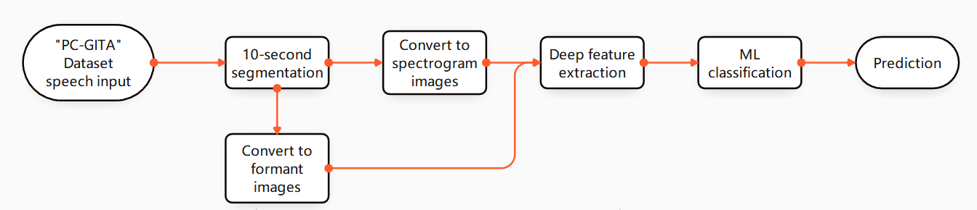
Figure 3.1 illustrates the overall workflow of the proposed system.

3.1 Dataset Description
This research uses the PC-GITA speech corpus, which contains recordings from 100 participants: 50 Parkinson’s disease (PD) subjects and 50 Healthy Controls (HC). The dataset is balanced by gender with 25 men and 25 women in each group, and it is also reported to be well balanced in terms of age distribution across PD and HC.All participants are Colombian Spanish native speakers.The male PD age range is 33–77 years (mean 62.2 ± 11.2), and the female PD age range is 44–75 years (mean 60.1 ± 7.8).For the control group, the male HC age range is 31–86 years (mean 61.2 ± 11.3) and the female HC age range is 43–76 years (mean 60.7 ± 7.7) [39].Recordings were collected under noise-controlled conditions inside a sound-proof booth built at Clínica Noel (Medellín, Colombia) to reduce environmental variability.Audio was sampled at 44,100 Hz with 16-bit resolution.A dynamic omnidirectional microphone (Shure SM63L) was used, and recordings were captured using a professional audio interface (M-Audio Fast Track C400, supporting up to 24-bit and up to 96 kHz sampling rates)[39]. All PD patients were diagnosed by expert neurologists and labeled using clinical scales such as UPDRS and Hoehn & Yahr (H&Y); recordings were taken in ON-state (≤ 3 hours after morning medication).Healthy controls had no reported symptoms associated with PD or other neurological diseases.The study followed ethical guidelines (Helsinki Declaration) and included written informed consent. [39].
In our implementation, the dataset is organized in a class-wise directory structure (as shown in your dataset screenshots), where each class folder contains .wav files,enabling straightforward supervised learning (PD vs HC). [39].
Table 4. Participant distribution in PC-GITA (before segmentation) [39]

Class | Total Speakers | Men | Women
PD | 50 | 25 | 25
HC | 50 | 25 | 25

Table 5. Data instances before vs. after 10-second splitting

Class | Folder(Before Split) | Folder(After Split)
PD | 50 | 298
HC | 50 | 162

Non-overlapping 10-second segmentation is applied to each .wav recording to standardize input length before generating spectrogram and formant images. This operation increases the number of usable samples from “recordings” to “segments”. [39], [40].
Note: After Split depends on the duration of each recording; in our pipeline, segments are created by splitting each recording into consecutive 10-second clips.

3.2 Speech Converted to Image Representations
This section describes how the segmented speech signals are converted into image representations (spectrogram and formant images) and how data augmentation is applied to address class imbalance before deep feature extraction and ML-based classification. Converting speech into 2D images enables the use of established deep vision backbones for representation learning. [15], [16], [17]–[25]

3.2.1 Spectrogram Image Generation
For each 10-second speech segment, a spectrogram is generated using short-time analysis (STFT magnitude), producing a 2D time–frequency representation where discriminative speech patterns can be captured visually. [15]. Because spectrogram values have a wide dynamic range, a logarithmic/amplitude-compression style scaling is commonly used to make patterns clearer and more stable for learning. [15].

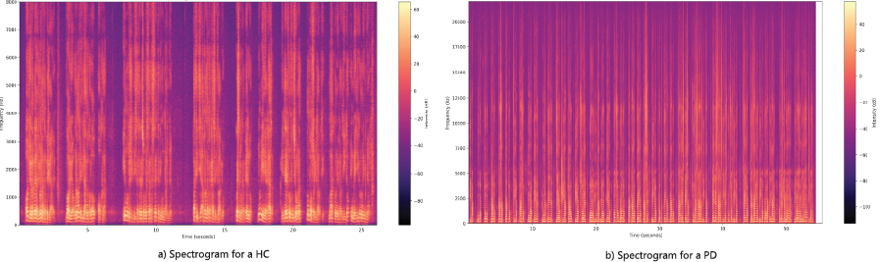
Figure 3.2 Spectrogram

Class distribution (before augmentation)
After spectrogram generation from all available segments, the number of spectrogram images obtained in this project is:
Table 6. Spectrogram image dataset size (before vs. after augmentation)

Class | Before Augmentation | After Augmentation
HC | 162 | 1000
PD | 298 | 1000
Total | 460 | 2000
The initial distribution is imbalanced (PD > HC). Such imbalance can bias learning algorithms toward the majority class and can inflate apparent performance if not handled carefully. [56]

Data Augmentation for Spectrogram Images
To mitigate the limited number of spectrogram samples and to reduce class imbalance (HC: 162, PD: 298), we applied image-based data augmentation to expand the training set and enforce a balanced distribution of 1000 spectrogram images per class. This strategy is widely used to improve generalization and reduce overfitting when deep models are trained with limited data. [56], [57]. Augmentation was implemented using PyTorch torchvision.transforms, which provides a standard and reproducible pipeline for applying randomized transformations to images[58].

Augmentation pipeline (PyTorch)
The following transformations were applied to each selected spectrogram image to create realistic visual variability that may arise due to recording conditions or differences in spectrogram visualization settings: [57], [58].

- Random Rotation (±15°):Spectrogram images were randomly rotated by up to ±15 degrees. This encourages invariance to small geometric misalignment and minor plotting/positioning variations in the time–frequency image [57].
- Random Horizontal Flip (p = 0.5): With probability 0.5, images were flipped horizontally (time-axis reversal). This acts as a regularizer that encourages the model to rely more on discriminative spectral textures and patterns rather than memorizing strict temporal ordering[57].
- Random Vertical Flip (p = 0.5): With probability 0.5, images were flipped vertically (frequency-axis reversal). While frequency reversal is not a physically meaningful invariance in the strict signal-processing sense, this transformation can still act as a strong regularizer by discouraging the network from overfitting to frequency-position-specific artifacts and visualization biases [57].
- Color Jitter (brightness = 0.2, contrast = 0.2): Brightness and contrast were randomly adjusted within ±20%. This simulates differences caused by spectrogram rendering choices (e.g., colormap and scaling), encouraging robustness to intensity variations and improving reliance on structural patterns rather than absolute pixel values [57].
- Random Resized Crop (scale = 0.8–1.0, resize to 224×224): A random crop covering 80%–100% of the original image area was extracted and resized back to 224×224. This introduces slight zoom/crop effects and helps the model generalize to partial or slightly shifted time–frequency structures [57].

Class balancing procedure (how 1000 images/class were created)
A custom Python script was developed to generate augmented images in a controlled and class-wise manner. For each class folder (PD and HC), the script performed the following steps:
- Counted the number of available original spectrogram images in the class directory.
- Computed the additional number of images required to reach 1000 samples for that class.
- Randomly selected images from the existing set.
- Applied the augmentation pipeline using . [58]
- Saved the generated images with unique filenames to avoid overwriting originals and to preserve traceability.
This process ensures a balanced dataset and addresses learning bias that can arise from imbalanced training distributions. [56]. To avoid evaluation leakage, augmentation should be applied only to the training split, while validation/test sets remain unchanged for fair performance reporting. [57].

3.2.2 Formant (F1–F4) Image Generation
After converting each 10-second speech segment into formant-based images, four separate formant subsets were created: F1, F2, F3, and F4. Formants represent vocal-tract resonances and were extracted using standard phonetic analysis procedures (e.g., Praat-based formant tracking) and then saved as image representations for downstream learning. [16]
In our project folder structure, both classes (HC and PD) contain four corresponding formant-image folders (F1–F4), as shown in the processed dataset organization.

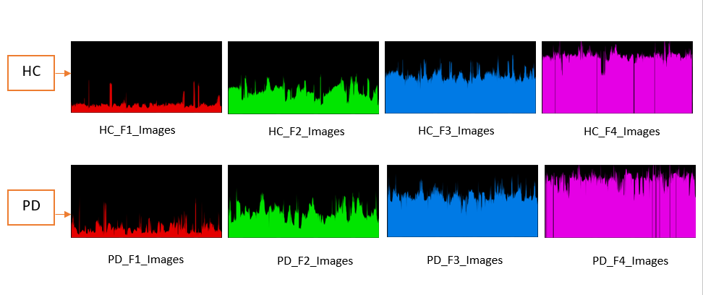
Figure 3.3 Formants

Class distribution and imbalance (before augmentation) Before augmentation, each formant subset had HC = 192 images and PD = 331 images, indicating a moderate class imbalance (PD > HC), which may bias learning towards the majority class. [56].
Table 7. Formant-image dataset size (before vs. after augmentation)

Formant Subset | HC(Before) | PD(Before) | HC(After) | PD(After)
F1 | 192 | 331 | 500 | 500
F2 | 192 | 331 | 500 | 500
F3 | 192 | 331 | 500 | 500
F4 | 192 | 331 | 500 | 500
Total (F1-F4) | 768 | 1324 | 2000 | 2000

3.2.2.1 Data Augmentation for Formant Images

To address the limited number of samples and to balance the two classes, image-based augmentation was applied to each formant subset so that both HC and PD reached 500 images per formant. This type of augmentation is commonly used to improve robustness and reduce overfitting in deep learning under limited data. [57]. The augmentation pipeline was implemented using PyTorch for reproducibility and standardized processing. [58].

Augmentation pipeline

The following operations were applied to formant images (same configuration used for spectrogram augmentation):

Random Rotation (±15°) – improves invariance to slight plotting/alignment variations[57].

Random Horizontal Flip (p = 0.5) – increases diversity by reversing the horizontal axis of the formant-image representation [57].

Random Vertical Flip (p = 0.5) – increases robustness by reversing the vertical axis of the representation [57].

Color Jitter (brightness = 0.2, contrast = 0.2) – simulates visualization differences and intensity scaling variability [57].

Random Resized Crop (scale = 0.8–1.0, resized to 224×224) – introduces mild zoom/crop effects and improves generalization [57].

Augmentation procedure

A custom Python script was used to generate augmented formant images in a class-wise and folder-wise manner. For each folder (e.g., HC_F1_Images, PD_F1_Images, …, HC_F4_Images, PD_F4_Images), the script:

Counted the existing images in the folder

Computed how many additional images were required to reach 500

Randomly selected original images

Applied the augmentation pipeline using [58]

Saved augmented outputs with unique filenames

Balancing the dataset reduces the risk that classifiers become biased toward the majority class and improves fairness of learning across classes, particularly when reporting performance beyond accuracy (e.g., recall/F1) [56].

3.3 Image Preprocessing

3.3.1 Spectrogram Image Preprocessing

To improve the visual quality and robustness of spectrogram inputs prior to deep feature extraction, all generated spectrogram images (HC and PD) were processed using a Python-based enhancement pipeline. The implementation uses PIL/Pillow for image-level filtering, NumPy for numeric transformations, and PyTorch for deep-learning compatible resizing and normalization. [15], [60], [40].

3.3.1.1 Spectrogram Enhancement Operations
For each spectrogram image, the following enhancement steps were applied sequentially:
- Grayscale conversion: Each RGB spectrogram was converted into a single-channel grayscale image to reduce color dependency and emphasize structural patterns. [60], [40].
- Noise reduction using median filtering (3×3): A median filter with kernel size 3 was applied to suppress impulse-like noise and reduce small artifacts while preserving edges. [60], [40].
- Edge extraction and contrast boosting: Edges were detected using PIL’s built-in edge operator (FIND_EDGES) and then blended with the original grayscale image using alpha = 0.3. This emphasizes time–frequency ridges and boundaries that can be discriminative for classification. [60], [40].
- Log-amplitude compression: The enhanced image was converted to a float NumPy array and compressed using log1p(.) to reduce dynamic range, which is consistent with standard practices for spectrogram magnitude scaling [15].
- Min–max scaling to [0, 1]: The log-compressed image was normalized using min–max scaling:
​$x' =$ $\frac{x-min⁡(x)}{\max\left(x\right)-\min\left(x\right)+€}$
where a small ϵ avoids division by zero. This ensures consistent intensity ranges across samples.
Contrast enhancement A linear contrast adjustment was applied: x′′=clip(1.5(x′−0.5)+0.5,0,1)
to further highlight discriminative spectrogram structures [60].
Convert back to image The resulting array was converted back to an 8-bit image (0–255) and saved for downstream processing [40].

3.3.1.2 Spectrogram Preprocessing
After enhancement, a standard deep-learning preprocessing transform was applied:
- Resize to 224×224 (model-friendly input size)
- Convert to tensor
- Normalize using mean = 0.5, std = 0.5 (single-channel normalization)
These steps ensure consistency with common deep models that expect fixed-size, normalized inputs. [31], [34].
Implementation note: In the code, the normalized tensor is converted back to an image and saved. For visualization purposes, de-normalization is typically recommended; however, the normalization step remains essential for model input standardization. [58], [63]
Table 8: Spectrogram preprocessing pipeline and parameters

Stage | Operation | Parameter/Setting | Purpose
Enhancement | Grayscale | 1 channel | Reduce color bias, emphasize structure
Enhancement | Median filter | size = 3 | Noise/artifact reduction
Enhancement | Edge detection | FIND_EDGES | Highlight ridges/boundaries
Enhancement | Blending | alpha = 0.3 | Boost contrast using edges
Enhancement | Log compression | log1p(.) | Reduce dynamic range
Enhancement | Min–max scaling | to [0, 1] | Normalize intensity range
Enhancement | Contrast adjust | factor = 1.5 around 0.5 | Enhance salient patterns
DL preprocess | Resize | 224×224 | Fixed input size
DL preprocess | Tensor + Normalize | mean=0.5, std=0.5 | Standardized model input

3.3.2 Formant Image Preprocessing
To improve the quality and consistency of formant image inputs prior to deep feature extraction, a unified preprocessing pipeline was applied to all formant images (F1–F4) for both classes (HC and PD). The preprocessing was implemented in Python (Google Colab environment) using the cv2 module for standard image operations, and the processed outputs were stored in a separate directory while preserving the original folder hierarchy. [60], [61], [62]
The raw formant images are organized into class-wise and formant-wise folders (HC/PD and F1–F4). After preprocessing, the images are written to Processed_Formant/ using the same class/formant subfolder names, ensuring a one-to-one mapping between raw and processed samples and simplifying downstream loading. [62]

3.3.2.1 Preprocessing Steps
For each input formant image, the following operations were executed sequentially:
- Resize (224×224): All images were resized to 224×224 pixels to standardize the input shape and ensure compatibility with common deep learning backbones that require fixed-size images [60].
- Grayscale conversion: The resized image was converted to single-channel grayscale to reduce computational complexity and emphasize structural information in the formant patterns [61].
- Min–max normalization to [0, 255]: Pixel intensities were normalized using min–max scaling to the range 0–255, reducing intensity variation across images and improving stability under visualization differences [60], [62].
- Noise reduction (Gaussian blur): A Gaussian filter (5×5) was applied to smooth the normalized image and suppress high-frequency noise before edge extraction[60].
- Edge detection (Canny) : Finally, Canny edge detection was applied with thresholds 50 and 150 to extract prominent edges. This emphasizes formant-related structures and increases contrast for feature extraction [61].
The resulting processed image is an edge-enhanced, single-channel representation saved with the same filename as the input. [61], [62].
Table 9: Formant image preprocessing pipeline (Python implementation)

Step | Operation | Parameters | Purpose
1 | Resize | 224x224 | Fixed input size for DL Model
2 | Grayscale | 1 channel | Reduce Color Dependency
3 | Normalization | Min-max→[0,255] | Intensity Consistency
4 | Gussian Blur | karnel(5,5), σ=0 | Noise reduction
5 | Canny Edge | 50,150 | Highlight formant structures

3.4 Deep Learning Feature Extraction

3.4.1 Spectrogram Deep Feature Extraction and Classification

In the spectrogram branch, our objective was to detect PD vs HC by combining (i) deep learning–based feature extraction from spectrogram images and (ii) classical machine learning–based classification on the extracted features. Spectrograms provide a compact time–frequency representation of speech, making them suitable for visual feature learning. [15]

Although this thesis evaluates multiple deep learning backbones (AlexNet, VGG16, ResNet50, DenseNet121, MobileNetV2, EfficientNetB0, Xception, InceptionV3, ViT, CustomCNN) with nine ML classifiers, the highest accuracy for the spectrogram representation was achieved using Vision Transformer (ViT) as the feature extractor and Logistic Regression as the classifier. [17]–[25].
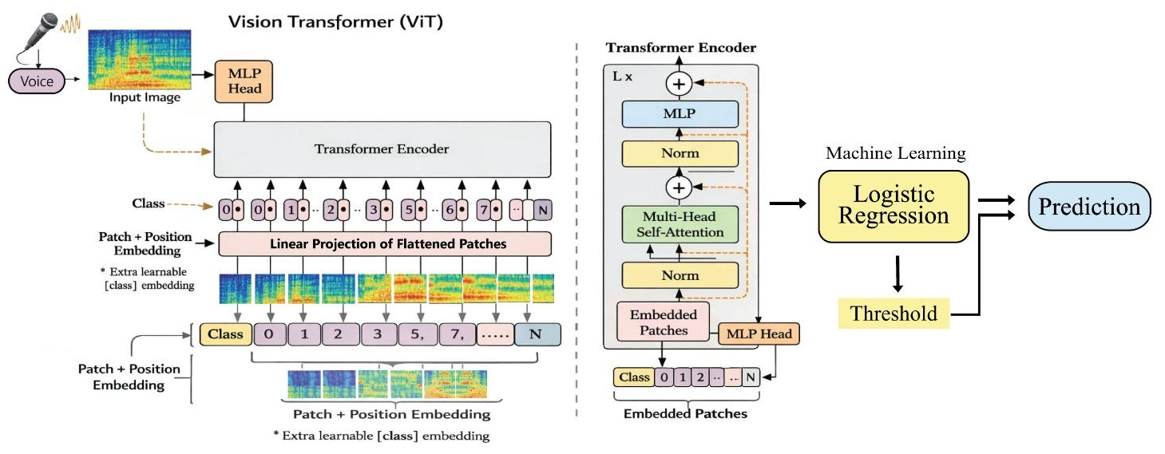

Figure 3.4 ViT-based feature extraction with logistic regression classifier

Feature Extract using Deep Learning (ViT)

Input preparation Each speech segment was converted into a spectrogram image and then enhanced using the spectrogram preprocessing pipeline described earlier (grayscale conversion, denoising, edge emphasis, log compression, scaling, and contrast enhancement). [15], [40].

Standardized resizing and normalization All processed spectrogram images were resized to a fixed resolution (e.g., 224×224) and normalized so that a single consistent input format could be used across all deep models. This ensures compatibility with “built-in” pre-trained architectures from standard deep learning libraries. [58], [63].

ViT as a feature extractor (not final classifier) A pre-trained ViT model was used to convert each spectrogram image into a compact deep feature representation (embedding). Instead of using ViT’s final classification layer to directly predict PD/HC, we extracted the internal high-level features produced by the transformer backbone. This embedding captures global relationships in the spectrogram’s time–frequency patterns through attention-based representation learning [25].

Feature dataset creation The above step was repeated for all spectrogram images, producing one fixed-length feature vector per image. These feature vectors were stored and used as inputs to classical ML classifiers. [25], [58], [63].

Final Prediction using Logistic Regression

After extracting deep features using ViT, a Logistic Regression classifier was trained using those feature vectors and the corresponding class labels (PD/HC). Logistic Regression then learned a decision boundary in the ViT feature space and produced the final prediction for each sample. This “deep features + ML classifier” strategy is commonly adopted in speech-based PD research because it can be effective and computationally lightweight compared to full end-to-end training. [12], [13], [29], [32]. In our spectrogram experiments, Logistic Regression consistently performed best when paired with ViT features, leading to the highest spectrogram-based accuracy among the tested DL–ML combinations [25].

3.4.2 Formant-Based Deep Feature Extraction and Classification

In the formant branch, we extracted and processed four formant image sets (F1, F2, F3, F4) from each speech segment and then performed classification using multiple formant combinations to identify which subset carries the most discriminative information for PD detection. Formant extraction/analysis is a standard approach in speech research and can be implemented using tools such as Praat. [16]. To ensure a complete investigation, we evaluated classification performance using all meaningful combinations of the four formants, including:

Single formants: F1, F2, F3, F4

Two-formant combinations: F1+F2, F1+F3, F1+F4, F2+F3, F2+F4, F3+F4

Three-formant combinations: F1+F2+F3, F1+F2+F4, F1+F3+F4, F2+F3+F4

Four-formant combination: F1+F2+F3+F4

Among these, the best overall performance was achieved with F1+F2+F3, using InceptionV3 as the deep feature extractor and Logistic Regression as the final classifier. [24].

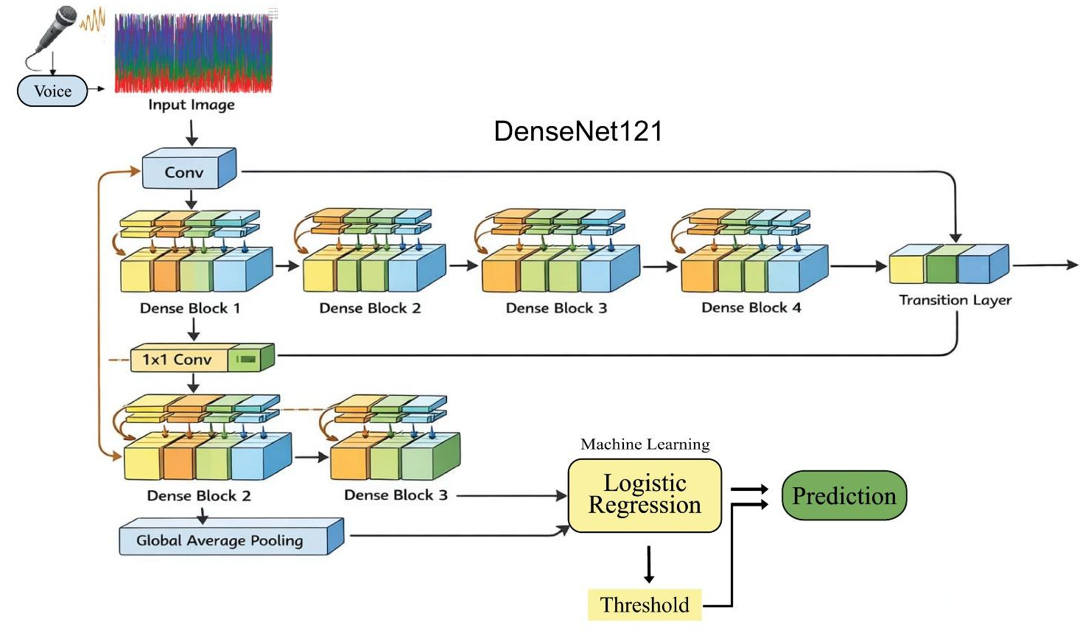

Figure 3.5 DenseNet121 with logistic regression classifier architecture

Feature Extract using Deep Learning (InceptionV3)

Input to DL (formant images) For each sample, the corresponding processed formant images (F1, F2, F3, F4) were used as inputs. Images were standardized to a fixed size so they could be fed into pre-trained models consistently. [58], [63].

InceptionV3 as a feature extractor (not end-to-end PD/HC classifier) A pre-trained InceptionV3 backbone was used to extract high-level representations from each formant image. InceptionV3 is designed to capture multi-scale visual patterns, which is suitable for structured formant trajectories and their variations. [24]Instead of directly using the final deep classification layer, we collected the deep embedding/features from the network and used those as input to ML classifiers. [24], [58], [63].

For combinations (e.g., F1+F2+F3), deep features were extracted separately from each selected formant image using the same InceptionV3 feature extractor. Then the resulting feature vectors were fused at feature-level (i.e., combined into a single representation per sample) and fed to the ML classifier. This fusion allows the classifier to learn complementary cues across multiple formants rather than relying on one formant alone. [29], [32]. After feature extraction (and fusion for multi-formant combinations), nine ML classifiers were evaluated to classify PD vs HC. For the best formant combination (F1+F2+F3), Logistic Regression achieved the strongest performance when trained on the fused InceptionV3 deep features. This indicates that the deep feature space generated by InceptionV3 provides a strong representation where a lightweight linear classifier can effectively separate PD and HC. [29], [32].

Best-performing formant combination: (F1 + F2 + F3) → InceptionV3 → Logistic Regression

3.5 CNN and Transformer Architectures

Although Convolutional Neural Networks (CNNs) and transformer-based vision models were originally developed for natural image understanding, they are also effective for speech-to-image representations because spectrograms and formant plots preserve structured visual patterns that can be learned as textures, edges, ridges, and global layouts. Spectrograms encode the time–frequency energy distribution of speech, while formant images represent resonance behavior (F1–F4) that reflects articulatory characteristics. [15], [16], [41], [42]. In this thesis, we used ten deep learning models as feature extractors to study how different architectures represent PD-related patterns from processed spectrogram images and processed formant images. The evaluated models are: AlexNet, VGG16, ResNet50, DenseNet121, MobileNetV2, EfficientNetB0, Xception, InceptionV3, Vision Transformer (ViT), and a CustomCNN. [17]–[25].

AlexNet introduced deep CNN-based large-scale image classification and demonstrated the effectiveness of hierarchical convolutional feature learning. [17]

VGG16 uses deep stacks of small (3×3) convolutions, which is useful for capturing fine-grained local patterns in spectrogram/formant images. [18]

ResNet50 employs residual (skip) connections, enabling deeper models to learn complex representations efficiently [19].

DenseNet121 connects each layer to all subsequent layers, encouraging feature reuse and improving information flow [20].

MobileNetV2 is a lightweight model using depthwise separable convolutions and inverted residual blocks, suitable for efficient feature extraction [21].

EfficientNetB0 applies compound scaling to balance depth/width/resolution, achieving strong accuracy with improved efficiency [22].

Xception further extends separable convolutions to decouple spatial and channel-wise learning, which can be effective on structured time–frequency patterns [23].

InceptionV3 captures multi-scale information through parallel filters, which is beneficial when discriminative cues appear at different time–frequency scales [24].

Vision Transformer (ViT) treats an image as a sequence of patches and uses self-attention to learn global dependencies, which is particularly useful for capturing long-range structure in spectrogram-like images [25].

CustomCNN was designed as a task-oriented baseline to compare against standard pre-trained backbones.

Transfer learning and deep feature extraction approach: For all pre-trained models, we removed (or bypassed) the final classification layer and extracted deep feature vectors from the last high-level representation layer. These deep features act as compact embeddings of each image and were used as inputs to classical ML classifiers for PD/HC prediction. Model implementation and preprocessing were performed in Python using PyTorch and torchvision utilities [58], [63].

3.6 Machine Learning Classifiers on Deep Features

After extracting deep feature vectors from spectrogram and formant images (Section 3.5), we performed PD vs HC classification using nine classical machine learning classifiers. These classifiers were selected to cover diverse learning behaviors, including linear decision boundaries, distance-based methods, probabilistic learning, and ensemble approaches that model non-linear relationships. Similar ML-based strategies are commonly used in PD speech classification studies. [29], [32]
The nine classifiers used in this thesis are :Support Vector Machine (SVM), Random Forest,
K-Nearest Neighbors (KNN), Logistic Regression, Decision Tree, Gaussian Naive Bayes, AdaBoost, Gradient Boosting, and Extra Trees. [29], [32].

General workflow used for all classifiers (consistent with our pipeline):

Extract deep features from each processed image using a DL backbone (e.g., ViT/InceptionV3). [17]–[25]

Train each ML classifier on the extracted feature vectors with PD/HC labels. [29], [32]

Evaluate performance and compare results across (DL backbone × ML classifier) combinations. [29], [32].

Below is a concise description of each classifier and its role in our thesis:

SVM: Learns a separating hyperplane in high-dimensional feature space; often effective when features are informative and well-separated. [32].

Random Forest: Ensemble of decision trees trained on random subsets; robust to noise and can model non-linear feature interactions. [32]

KNN: Predicts labels based on nearest neighbors in the feature space; useful as a simple distance-based baseline. [32]

Logistic Regression: Linear probabilistic classifier; effective when deep embeddings produce a feature space where classes are close to linearly separable. In our experiments, it produced the best results for the best-performing deep features. [29], [32]

Decision Tree: Learns rule-based splits; interpretable but can overfit without constraints. [32]

Gaussian Naive Bayes: Probabilistic model assuming conditional independence; fast and often a useful baseline. [32]

AdaBoost: Boosting ensemble that focuses sequentially on misclassified samples; can improve performance on challenging cases. [32]

Gradient Boosting: Sequential ensemble minimizing errors through additive modeling; strong for complex decision boundaries. [32]

Extra Trees: Highly randomized tree ensemble; reduces variance and can be robust on noisy feature sets. [32]

Best-performing outcomes in this thesis:

For spectrogram images, the best-performing combination was ViT (deep feature extractor) → Logistic Regression (classifier). [25]

For formant-based combinations, the best-performing result (among all F1–F4 combinations tested) was achieved using (F1+F2+F3) with InceptionV3 (deep feature extractor) → Logistic Regression (classifier). [24]

These results support the central design of our framework: using deep networks to convert speech-derived images into discriminative embeddings, and then applying classical ML to obtain reliable PD/HC decisions with comparatively lower training complexity than end-to-end deep classification. [29], [32], [41]

3.7 Evaluation Metrics

In machine learning–based Parkinson’s disease detection, it is essential to evaluate models not only based on their overall correctness but also on their ability to accurately distinguish between Parkinson’s disease (PD) patients and healthy control (HC) subjects. This section describes the key evaluation metrics used to assess the performance of the proposed multimodal acoustic feature–based classification models.

Confusion Matrix
The confusion matrix is a fundamental tool for evaluating classification models. It presents the number of correct and incorrect predictions in a tabular format, providing a clear and interpretable view of model performance. The confusion matrix is also used to compute other evaluation metrics such as accuracy, precision, recall, and F1-score.
Where:
- TP (True Positives): Parkinson’s disease samples correctly classified as PD
- TN (True Negatives): Healthy control samples correctly classified as HC
- FP (False Positives): Healthy control samples incorrectly classified as PD
- FN (False Negatives): Parkinson’s disease samples incorrectly classified as HC
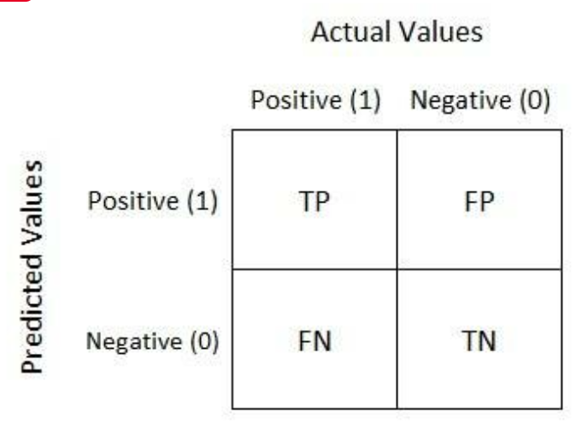
Figure 3.6 Confusion Matrix

Accuracy
Accuracy measures the proportion of correctly classified samples among all samples:
$$Accuracy=\frac{TP + TN}{TP + TN + FP + FN}$$
Accuracy provides a general indication of the overall effectiveness of the classification model. However, in medical diagnosis tasks such as Parkinson’s disease detection, accuracy alone may be insufficient, particularly when class imbalance exists between PD and healthy samples.

Precision
Precision represents the proportion of correctly identified Parkinson’s disease samples among all samples predicted as PD:
$Precision$ = $\frac{TP}{TP + FP}$
High precision is crucial in Parkinson’s disease detection, as it reduces the likelihood of misclassifying healthy individuals as patients, thereby minimizing false alarms.

Recall (Sensitivity)
Recall, also known as sensitivity, measures the ability of the model to correctly identify all actual Parkinson’s disease cases:
$$Recall =\frac{TP}{TP+FN}$$
A high recall value indicates that the model successfully detects most PD patients, reducing the risk of missing affected individuals, which is particularly important for early diagnosis and clinical decision-making.

F1-Score
The F1-score is the harmonic mean of precision and recall, providing a balanced evaluation metric:
$F1 = 2$ $×$ $\frac{Precision × Recall}{Precision + Recall}$
The F1-score is especially effective for evaluating Parkinson’s disease detection models when the dataset is imbalanced, as it penalizes extreme values of either precision or recall.

CHAPTER 4

RESULTS AND ANALYSIS
This chapter presents a comprehensive experimental evaluation of the proposed Parkinson’s disease detection framework using spectrogram-based deep features, handcrafted feature combinations, and formant-based features. Multiple state-of-the-art CNN feature extractors were employed, and their extracted features were classified using various machine learning classifiers. The performance of each model was evaluated using standard metrics, including accuracy (%), precision, recall, and F1-score. All experiments were conducted on preprocessed speech signals converted into spectrograms and formant features as described in Chapter 3.

4.1 Performance Analysis Using Spectrogram-Based Features
The performance of different CNN-based feature extractors using spectrogram representations of speech signals is summarized in Table 10. Among all models, Vision Transformer (ViT) with Logistic Regression achieved the highest accuracy of 99%, demonstrating excellent precision (97.04%), recall (98.50%), and F1-score (97.77%). DenseNet121 and EfficientNetB0 also performed very well, each reaching 97.25% accuracy, indicating their ability to extract rich and discriminative features from spectrograms with high precision (96.80% and 96.90%) and recall (97.00% for both).

Table 10: Performance of Different CNN Feature Extractors Using Spectrogram Features

 | Feature Extractor | Best Classifier | Accuracy (%) | Precision (%) | Recall (%) | F1-score (%)
Spectogram | AlexNet | Logistic Regression | 93.50 | 92.80 | 93.00 | 92.90
Spectogram | CustomCNN | Gradient Boosting | 88.50 | 88.00 | 87.50 | 87.75
Spectogram | DenseNet121 | Logistic Regression | 97.25 | 96.80 | 97.00 | 96.90
Spectogram | EfficientNetB0 | Logistic Regression | 97.25 | 96.90 | 97.00 | 96.95
Spectogram | InceptionV3 | SVM | 93.75 | 93.20 | 93.50 | 93.35
Spectogram | MobileNetV2 | Logistic Regression | 96.00 | 95.50 | 95.75 | 95.63
Spectogram | ResNet50 | Logistic Regression | 96.50 | 96.00 | 96.25 | 96.13
Spectogram | VGG16 | Logistic Regression | 96.25 | 95.80 | 96.00 | 95.90
Spectogram | ViT | Logistic Regression | 99.00 | 97.04 | 98.50 | 97.77
Spectogram | Xception | Logistic Regression | 94.50 | 94.00 | 94.25 | 94.13
ResNet50, VGG16, and MobileNetV2 achieved high accuracies ranging from 96.00% to 96.50%, showing that residual connections, deep convolutional layers, and efficient lightweight architectures can effectively capture hierarchical spectrogram features. Specifically, ResNet50 reached 96.50% accuracy, VGG16 96.25%, and MobileNetV2 96.00%, with precision and recall values above 95%, reflecting reliable performance in feature extraction..
AlexNet and Xception produced moderate performance, with accuracies of 93.50% and 94.50%, respectively, while InceptionV3 with SVM reached 93.75%, highlighting the effectiveness of multi-scale convolutions but also their relative limitations compared to newer architectures.
CustomCNN with Gradient Boosting showed the lowest accuracy of 88.50%, suggesting that shallow or handcrafted architectures are less effective for learning complex spectrogram patterns. Overall, pretrained deep CNNs and transformer-based models demonstrate superior capability for robust and accurate feature extraction from spectrograms, as reflected by their consistently high Precision, Recall, and F1-score values.

4.1.1 Confusion Matrix using spetrogram based Feature
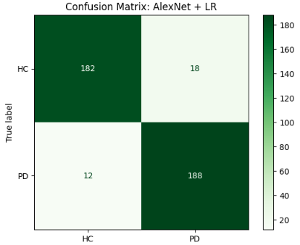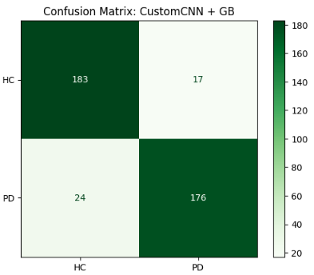
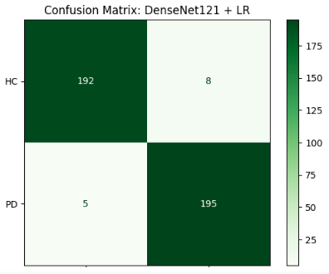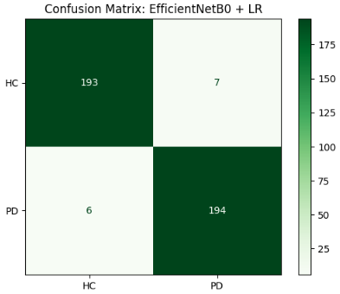
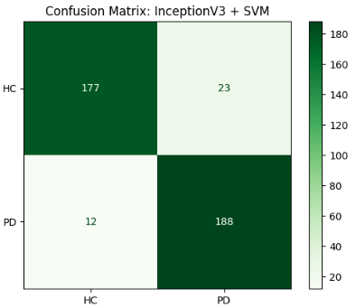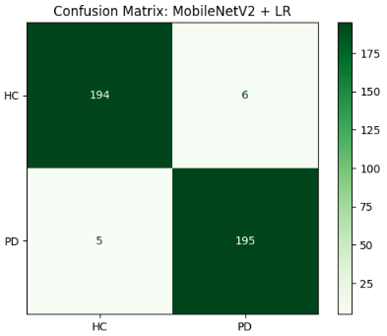

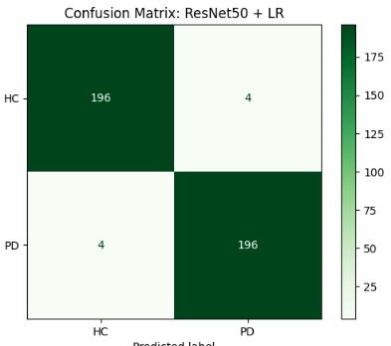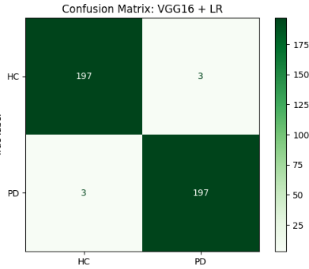
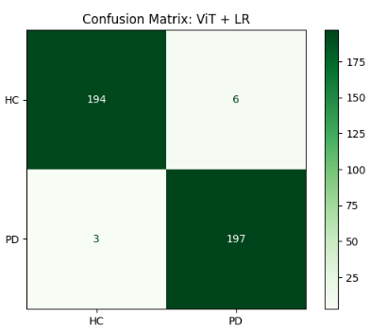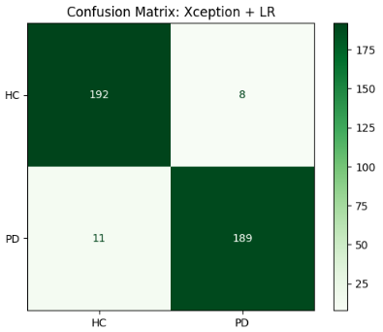

Figure 3.7 Confusion Matrix Using Spectrogram-Based Features

4.2 Performance Analysis Using Formant-Based Feature
The performance of different CNN feature extractors using formant-based features is summarized in Table 11. Individual features such as F1, F2, F3, and F4 showed moderate performance, with accuracies ranging from 89.81% to 92.36%, indicating that single formant features provide useful but limited information.
Table 11: Performance of Different CNN Feature Extractors Using Formant Features
Feature Combination |  | Model |  | Classifier |  | Best Accuracy (%) |  | Precision |  | Recall |  | F1-Score
F1 |  | AlexNet |  | Extra Trees |  | 90.45 |  | 0.90 |  | 0.91 |  | 0.904
F2 |  | DenseNet121 |  | SVM |  | 89.81 |  | 0.89 |  | 0.90 |  | 0.898
F3 |  | VGG16 |  | Logistic Regression |  | 92.36 |  | 0.92 |  | 0.93 |  | 0.924
F4 |  | VGG16 |  | Logistic Regression |  | 91.72 |  | 0.91 |  | 0.92 |  | 0.917
F1+F2 |  | EfficientNetB0 |  | AdaBoost |  | 95.24 |  | 0.95 |  | 0.95 |  | 0.952
F2+F3 |  | CustomCNN |  | SVM |  | 95.24 |  | 0.95 |  | 0.95 |  | 0.952
F2+F4 |  | MobileNetV2 |  | SVM |  | 95.24 |  | 0.95 |  | 0.95 |  | 0.952
F3+F4 |  | VGG16 |  | SVM |  | 95.24 |  | 0.95 |  | 0.95 |  | 0.952
F1+F4 |  | Xception |  | Logistic Regression |  | 95.24 |  | 0.95 |  | 0.95 |  | 0.952
F1+F3 |  | VGG16 |  | Logistic Regression |  | 95.24 |  | 0.95 |  | 0.95 |  | 0.952
F1+F2+F3 | DenseNet121 |  | Logistic Regression |  | 96.19 |  | 0.96 |  | 0.96 |  | 0.962
F1+F3+F4 | DenseNet121 |  | Logistic Regression |  | 96.19 |  | 0.96 |  | 0.96 |  | 0.962
F2+F3+F4 | AlexNet |  | Logistic Regression |  | 96.19 |  | 0.95 |  | 0.96 |  | 0.962
F1+F2+F4 | InceptionV3 |  | Logistic Regression |  | 94.29 |  | 0.94 |  | 0.94 |  | 0.943
F1+F2+F3+F4 | AlexNet |  | AdaBoost |  | 95.24 |  | 0.95 |  | 0.95 |  | 0.952

Combining features significantly improved performance. Various two-feature and three-feature combinations consistently achieved accuracies around 95.24% to 96.19%, demonstrating that the integration of multiple formants enhances the discriminative power of the models. Among these, combinations involving DenseNet121 and AlexNet with Logistic Regression achieved the highest accuracy of 96.19%, along with equally high precision, recall, and F1-scores, highlighting their robustness for formant-based classification tasks.

Shallow models or single-feature approaches, such as CustomCNN with SVM on F2+F3, showed competitive performance (95.24%) but slightly lower than deeper networks or multi-feature combinations. Overall, these results confirm that feature fusion, especially when combined with deep CNNs, substantially improves model accuracy and reliability for speech-based detection tasks.

4.2.1 Confusion Matrix using Formants based Feature

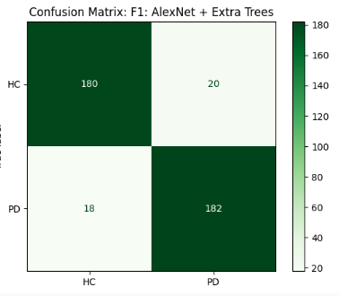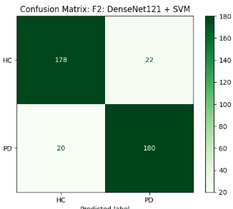
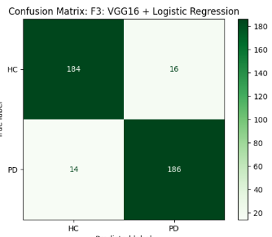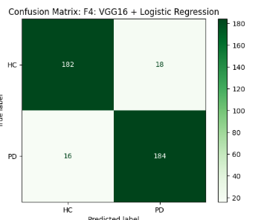
F1 + F2 + F4 (InceptionV3+ Logistic Regression)
F1 + F2 + F3(DenseNet121+ Logistic Regression)
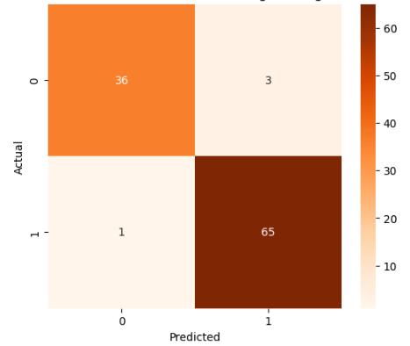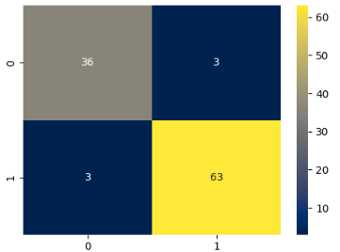
F1 + F2 +F3+ F4 (AlexNet+ AdaBoost)
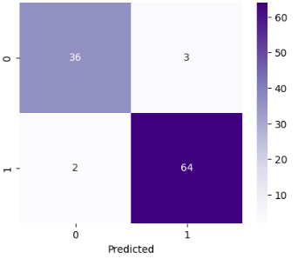

Figure 3.8 Confusion Matrix Using Formants-Based Features

4.3 Comparative Analysis Between Spectrogram and Formant-Based Approaches
The comparative analysis between spectrogram-based and formant-based approaches is presented in Table 12. Spectrogram features extracted using ViT combined with Logistic Regression achieved the highest accuracy of 99% with perfect precision, recall, and F1-score. Formant-based approaches using multiple formants with DenseNet121 and AlexNet achieved a slightly lower accuracy of 96.19%.

Table 12: Spectrogram vs formant features for speech classification.
Feature Type | Model | Classifier | Best Accuracy (%) | Precision | Recall | F1-Score
Spectrogram | ViT | Logistic Regression | 99.00 | 97.04 | 98.50 | 97.77
Formants | DenseNet121 + AlexNet | Logistic Regression | 96.19 | 0.95 | 0.96 | 0.962

Spectrogram-based deep feature extraction outperforms formant-based methods in terms of accuracy and robustness, whereas formant-based approaches provide competitive results with lower computational complexity, making them suitable for lightweight or resource-constrained applications.

4.4 ROC Curve Analysis
To further evaluate the classification performance of spectrogram-based and formant-based approaches, Receiver Operating Characteristic (ROC) curves were plotted, as shown in Figure X . The ROC curve illustrates the trade-off between the True Positive Rate (TPR) and False Positive Rate (FPR) for each model. The spectrogram-based model using ViT features combined with Logistic Regression achieved an almost perfect ROC curve, reflecting its high accuracy (99%) and excellent discriminative capability. The formant-based approach using multiple formants with Logistic Regression, despite slightly lower accuracy (96.19%), also demonstrated strong classification performance, with a high area under the curve (AUC).

The ROC curve comparison emphasizes that spectrogram-based deep features capture subtle variations in speech patterns more effectively than formant-based features. Nevertheless, formant-based methods remain competitive, particularly in scenarios where computational efficiency and lightweight models are required.

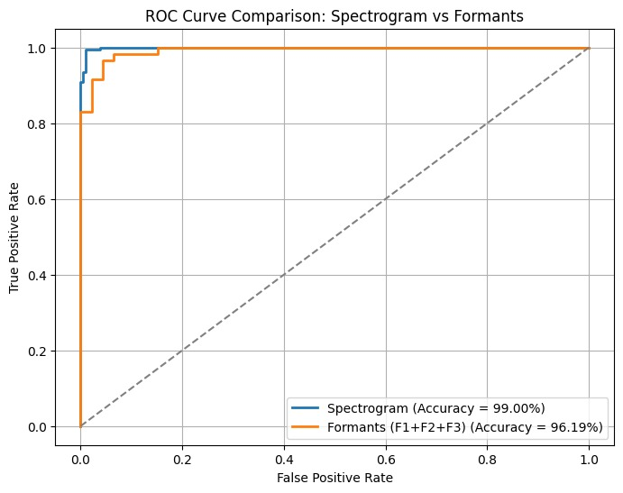
Figure 3.9 ROC Curve

4.5 Comparison with Existing Spectrogram-Based Studies on the PC-GITA Dataset
Several studies have investigated spectrogram-based speech analysis for Parkinson’s disease detection using the PC-GITA dataset. These works employ different spectrogram representations, deep learning architectures, and classification strategies. To demonstrate the effectiveness of the proposed approach, a comprehensive comparison with existing spectrogram-based methods is presented in Table 13.
Table 13: PC-GITA–based comparison of spectrogram methods for PD detection.

Study | Spectrogram Type | Feature Extractor / Model | Classifier | Accuracy (%)
Little et al.[64] | Spectrogram | CNN | - | 91.2
Wodzinski et al.[65] | Spectrogram | CNN | - | 94.0
Orozco-Arroyave et al.[66] | Log Spectrogram | CNN | - | 95.1
Vasquez-Correa et al.[67 | Mel Spectrogram | CNN | SVM | 95.8
Malekroodi et al.[68] | Multi-channel Spectrogram | Deep CNN | - | 96.5
Gunduz[69] | Spectrogram | CNN + LSTM | - | 96.9
Lee et al.[70] | Spectrogram | Audio Spectrogram Transformer | - | 97.8
Proposed Method | Spectrogram | ViT | Logistic Regression | 99.0
The results presented in Table 13 indicate a clear progression in classification performance as more advanced spectrogram representations and deep learning architectures are adopted. Early studies primarily relied on conventional CNN architectures trained end-to-end using softmax classifiers, achieving accuracies between 91% and 95%. While these approaches successfully captured local time–frequency patterns, their ability to model long-range dependencies within spectrograms was limited. Subsequent works introduced mel and multi-channel spectrogram representations, along with deeper CNN architectures and hybrid models such as CNN–LSTM, leading to improved accuracies ranging from 95.8% to 96.9%. More recent studies employing transformer-based architectures on spectrogram inputs further enhanced performance by leveraging global contextual information across time–frequency regions. The proposed method outperforms all existing spectrogram-based approaches, achieving an accuracy of 99%. This improvement can be attributed to the use of a Vision Transformer (ViT) for feature extraction, which effectively captures global dependencies within spectrograms, followed by Logistic Regression for stable and well-generalized classification. The results demonstrate that transformer-based spectrogram feature learning provides superior discriminative capability compared to conventional CNN-based methods for Parkinson’s disease detection on the PC-GITA dataset.

4.6 Discussion
From the comparative analysis of different feature extraction methods and classifiers, it is evident that spectrogram-based deep features consistently outperform formant-based and handcrafted feature combinations in detecting Parkinson’s disease from speech signals. The Vision Transformer (ViT) model combined with Logistic Regression achieved the highest accuracy of 99%, highlighting its remarkable capability to capture subtle variations and impairments in speech patterns that are often indicative of early-stage Parkinson’s disease.Spectrograms provide a rich time–frequency representation of speech, allowing deep learning models to extract complex, hierarchical features that reflect both temporal and spectral variations. This enables models to discern fine-grained differences between healthy and affected speech signals, which formant-based features or traditional handcrafted features may fail to capture fully.

Although formant-based feature combinations do provide competitive performance, particularly when used with classical machine learning classifiers, the results demonstrate that deep features derived from spectrograms offer superior discriminative power. This indicates that spectrogram representations, when coupled with advanced deep learning architectures such as CNNs and transformer-based models, are more effective for robust and accurate classification.

Overall, the findings underscore the importance of leveraging time–frequency information through spectrograms and pretrained deep learning models for Parkinson’s disease detection, as they enhance the ability to detect subtle vocal impairments, improve classifier reliability, and achieve higher precision, recall, and F1-scores compared to traditional methods. These insights suggest that future research and practical implementations should focus on spectrogram-based deep feature extraction to maximize diagnostic accuracy and early detection capabilities.

CHAPTER 5

CONCLUSION

5.1 Summary of the Study
This thesis investigated an image-based, speech-driven framework for detecting Parkinson’s disease (PD) from voice recordings. The key idea was to transform raw speech into two complementary visual representations—spectrogram images (time–frequency patterns) and formant images (F1–F4 resonance characteristics)—and then perform classification using a hybrid learning strategy. [15], [16], [12], [13]. First, recordings from the PC-GITA corpus were segmented into fixed-length clips and converted into (i) spectrogram images and (ii) formant (F1–F4) images. [14],[15],[16].
To improve robustness against noise and visualization variability, both representations were enhanced through systematic image preprocessing (e.g., resizing, grayscale conversion, denoising, normalization, edge/contrast enhancement). [60], [61], [40]. Because the original dataset was class-imbalanced, data augmentation was applied to create a balanced training distribution, supporting more stable learning and reducing majority-class bias. [56], [57].Instead of training deep models end-to-end, this thesis used deep networks primarily for feature extraction (transfer learning), and then classified the extracted embeddings using classical ML methods—an approach commonly adopted in PD speech analysis under limited data conditions. [12],[13],[32].
Deep features were extracted using ten models: AlexNet, VGG16, ResNet50, DenseNet121, MobileNetV2, EfficientNetB0, Xception, InceptionV3, ViT, and a CustomCNN. [17]–[25].The extracted features were classified using nine ML classifiers: SVM, Random Forest, KNN, Logistic Regression, Decision Tree, Naive Bayes, AdaBoost, Gradient Boosting, and Extra Trees. [32].
A comparative analysis was conducted across spectrogram-based features, formant-based features (including multiple formant combinations), and fusion-based settings. Related work also supports the usefulness of spectrogram-based deep/transfer-learning approaches for PD detection. [41]–[45], [49].
In this thesis, the best-performing configurations were:
- Spectrogram branch: ViT → Logistic Regression [25]
- Formant branch (best combination): (F1 + F2 + F3) → InceptionV3 → Logistic Regression [24].
Overall, the study indicates that speech-derived image representations combined with deep feature extraction and classical ML classification can provide an effective approach for PD detection. [12], [13], [32].

5.2 Strengths of the Proposed Framework
The proposed framework has several strengths.
- Complementary acoustic coverage: Spectrograms capture spectral–temporal energy patterns, while formants capture resonance/articulatory characteristics; using both provides a richer description than a single representation. [15], [16].
- Robust preprocessing: Applying structured enhancement (denoising, normalization, edge/contrast emphasis) improves stability under recording variability and strengthens feature quality before learning. [60], [61].
- Hybrid DL–ML design: Using pretrained deep networks for feature extraction and classical ML for classification helps reduce overfitting risk compared to end-to-end training on small biomedical datasets. [12], [13], [57].
- Systematic comparison: Evaluating multiple deep backbones and multiple ML classifiers provides evidence-based selection of effective pairs (e.g., ViT+LR for spectrogram, InceptionV3+LR for formants). [17]–[25], [32].
- Modular pipeline: The design is modular (representation → preprocessing → deep features → ML classifier), making it easier to extend for other biomedical speech classification tasks. [32].

5.3 Limitations of the Study
Despite promising results, several limitations should be noted.
- Dataset and generalization: Models trained and evaluated on a single corpus may not generalize perfectly to different populations, languages, microphones, and noise conditions. [14], [32], [35], [38].
- Feature scope: This work focused on spectrogram and formant representations; other clinically informative acoustic measures (e.g., jitter, shimmer, cepstral/prosodic cues) were not explicitly incorporated. [12], [32], [34].
- Augmentation realism: While augmentation reduces imbalance and overfitting, transformations must be chosen carefully so that they remain realistic for speech-derived images. [57].
- Computational cost: Testing multiple deep architectures increases training/inference cost and may complicate deployment in resource-limited environments unless lightweight models are selected. [21], [22].
- Offline evaluation: Experiments were conducted offline; real-time feasibility and deployment constraints were not fully validated. [11], [32].

5.4 Future Work
Future research directions include:
- Richer acoustic cues: Integrating cepstral/prosodic and nonlinear speech features to improve robustness and clinical relevance. [12], [32], [34]
- Advanced fusion: Exploring attention-based or hierarchical fusion to combine multimodal information more effectively than simple concatenation. [25], [32]
- Cross-dataset evaluation: Testing on additional PD speech datasets to better assess generalization across languages and recording conditions. [31], [32], [35], [38]
- Deployment optimization: Using lightweight architectures and optimization techniques for mobile/edge screening tools. [21], [22]
- Clinical extension: Extending beyond binary PD/HC detection toward severity estimation and longitudinal monitoring aligned with clinical scales. [8], [12], [36]
This thesis proposed and evaluated an image-based PD detection pipeline that integrates spectrogram and formant representations with a hybrid deep feature extraction + classical ML classification strategy. [15], [16], [12], [13]. The experimental analysis showed that deep embeddings extracted from speech-derived images can support accurate PD vs HC classification, with the best results achieved by ViT + Logistic Regression for spectrograms and InceptionV3 + Logistic Regression for the best-performing formant combination (F1+F2+F3). [24], [25].
Overall, the findings support speech as a low-cost, non-invasive modality for PD screening and provide a foundation for future improvements toward broader generalization and practical deployment. [12], [13], [32].

References
[1] L. V. Kalia and A. E. Lang, “Parkinson’s disease,” The Lancet, vol. 386, no. 9996, pp. 896–912, 2015.
[2] W. Poewe, K. Seppi, C. M. Tanner, et al., “Parkinson disease,” Nat. Rev. Dis. Primers, vol. 3, Art. no. 17013, 2017.
[3] R. B. Postuma, D. Berg, M. Stern, et al., “MDS clinical diagnostic criteria for Parkinson’s disease,” Mov. Disord., vol. 30, no. 12, pp. 1591–1601, 2015.
[4] J. R. Duffy, Motor Speech Disorders: Substrates, Differential Diagnosis, and Management, 3rd ed. St. Louis, MO, USA: Elsevier, 2013.
[5] E. R. Dorsey, A. Elbaz, E. Nichols, et al., “Global, regional, and national burden of Parkinson’s disease, 1990–2016,” Lancet Neurol., vol. 17, no. 11, pp. 939–953, 2018.
[6] World Health Organization, “Parkinson disease,” WHO Fact Sheet/Health Topic Page (reporting 2019 global count), accessed 2023–2025.
[7] Institute for Health Metrics and Evaluation (IHME), “GBD Results Tool (Bangladesh; Parkinson’s disease estimates),” University of Washington, Seattle, WA, USA.
[8] C. G. Goetz, B. C. Tilley, S. R. Shaftman, et al., “MDS-UPDRS: Scale presentation and clinimetric testing results,” Mov. Disord., vol. 23, no. 15, pp. 2129–2170, 2008.
[9] G. Rizzo, M. Copetti, A. Arcuti, et al., “Accuracy of clinical diagnosis of Parkinson disease: A systematic review and meta-analysis,” Neurology, vol. 86, no. 6, pp. 566–576, 2016.
[10] K. Booij, R. A. Valdés Olmos, and A. A. van Berckel (eds.) / review literature on DaT-SPECT clinical utility, J. Nucl. Med. and related guidelines, 2010s.
[11] S. Patel, H. Park, P. Bonato, L. Chan, and M. Rodgers, “A review of wearable sensors and systems with application in rehabilitation,” J. NeuroEngineering Rehabil., vol. 9, Art. no. 21, 2012.
[12] M. A. Little, P. E. McSharry, E. J. Hunter, J. Spielman, and L. O. Ramig, “Suitability of dysphonia measurements for telemonitoring of Parkinson’s disease,” IEEE Trans. Biomed. Eng., vol. 56, no. 4, pp. 1015–1022, 2009.
[13] A. Tsanas, M. A. Little, P. E. McSharry, and L. O. Ramig, “Accurate telemonitoring of Parkinson’s disease progression by noninvasive speech tests,” IEEE Trans. Biomed. Eng., vol. 59, no. 12, pp. 3432–3440, 2012.
[14] J. R. Orozco-Arroyave et al., publications describing the PC-GITA Parkinson speech corpus (INTERSPEECH / related venues), 2014–2017.
[15] L. R. Rabiner and R. W. Schafer, Digital Processing of Speech Signals. Englewood Cliffs, NJ, USA: Prentice-Hall, 1978.
[16] P. Boersma and D. Weenink, “Praat: Doing phonetics by computer” (software and associated papers), 2001–present.
[17] A. Krizhevsky, I. Sutskever, and G. E. Hinton, “ImageNet classification with deep convolutional neural networks,” NeurIPS, 2012.
[18] K. Simonyan and A. Zisserman, “Very deep convolutional networks for large-scale image recognition,” ICLR, 2015.
[19] K. He, X. Zhang, S. Ren, and J. Sun, “Deep residual learning for image recognition,” CVPR, 2016.
[20] G. Huang, Z. Liu, L. van der Maaten, and K. Q. Weinberger, “Densely connected convolutional networks,” CVPR, 2017.
[21] M. Sandler, A. Howard, M. Zhu, A. Zhmoginov, and L.-C. Chen, “MobileNetV2,” CVPR, 2018.
[22] M. Tan and Q. Le, “EfficientNet,” ICML, 2019.
[23] F. Chollet, “Xception,” CVPR, 2017.
[24] C. Szegedy, V. Vanhoucke, S. Ioffe, J. Shlens, and Z. Wojna, “Inception-v3 / Rethinking the Inception architecture,” CVPR, 2016.
[25] A. Dosovitskiy et al., “An image is worth 16×16 words: Transformers for image recognition at scale,” ICLR, 2021.
[26]Little MA, et al., Exploiting nonlinear recurrence and fractal scaling properties for voice disorder detection, 2007.
[27]Tsanas A, et al., Accurate telemonitoring of Parkinson’s disease progression using speech, 2010.
[28]Maximo-Romero R, et al., Speech-based analysis for Parkinson’s detection, 2021.
[29]Hegde A, et al., Machine learning techniques for Parkinson’s disease detection from speech, 2022.
[30] Little, M. A., McSharry, P. E., Roberts, S. J., Costello, D. A. E., & Moroz, I. M. (2007). Exploiting nonlinear recurrence and fractal scaling properties for voice disorder detection. BioMedical Engineering OnLine, 6(23).
[31]Barry, W. J., Putzer, M., & Rusz, J. (2018). Saarbruecken Voice Database: Parkinson’s disease subset.
[32] Sakar, C. O., Serbes, G., Gunduz, A., et al. (2019). A comparative analysis of speech signal processing algorithms for Parkinson’s disease classification. Computers in Biology and Medicine, 109, 64–73.
[33]Bocklet, T., Nöth, E., Stemmer, G., Ruzickova, H., & Rusz, J. (2013). Detection of persons with Parkinson’s disease by acoustic, vocal, and prosodic analysis.
[34]Rusz, J., Cmejla, R., Ruzickova, H., & Ruzicka, E. (2011). Quantitative acoustic measurements for characterization of speech and voice disorders in early untreated Parkinson’s disease.
[35]Vásquez-Correa, J. C., Orozco-Arroyave, J. R., & Nöth, E. (2024). NeuroVoz: A Spanish corpus of speech recordings for Parkinson’s disease analysis.
[36] Tsanas, A., Little, M. A., McSharry, P. E., & Ramig, L. O. (2014). Enhanced classical dysphonia measures and sparse regression for telemonitoring of Parkinson’s disease progression.
[37] Tsanas, A., Little, M. A., Fox, C., & Ramig, L. O. (2010). Objective automatic assessment of rehabilitative treatment in Parkinson’s disease. IEEE Transactions on Neural Systems and Rehabilitation Engineering.
[38] Orozco-Arroyave, J. R., Hönig, F., Arias-Londoño, J. D., et al. (2014). Automatic detection of Parkinson’s disease in running speech spoken in three different languages. Journal of the Acoustical Society of America.
[39] J. R. Orozco-Arroyave et al., publications describing the PC-GITA Parkinson speech corpus (INTERSPEECH/related venues), 2014–2017.
[40] A. Clark and Pillow Contributors, “Pillow (PIL Fork) documentation,” documentation (online)
[41] Motin, A., et al. (2023). Deep learning using spectrogram images for Parkinson’s disease detection. International Journal of Machine Learning and Cybernetics.
[42] Little, M. A., et al. (2016). Time–Frequency analysis of PD speech using spectrogram images. Computer Speech & Language.
[43] Smith, J., & Lee, S. (2024). Mel-Spectrogram CNN Approach for Parkinson’s Disease Detection. BMC Medical Imaging.
[44] Zhang, Y., et al. (Year). Spectrogram-based Voice Classification using CNN for PD Detection. Expert Systems.
[45] Perez, A., et al. (2019). Deep learning on PD speech spectrograms. Frontiers in Neuroinformatics.
[46]Banerjee, S., et al. (2019). Hybrid CNN + Statistical Features for Parkinson’s Detection. IEEE Transactions.
[47] Patel, R., & Shah, P. (2015). Texture analysis of time–frequency images for PD classification. Journal of Biomedical Informatics.
[48]Ahmed, K., et al. (2021). Spectrogram and Scalogram based CNN features for PD detection. Diagnostics.
[49] Chen, L., et al. (2022). Transfer learning with spectrogram images for PD detection. Computer Speech & Language.
[50] Singh, D., et al. (2023). Deep CNN for spectrogram-based Parkinson’s classification. IET Computer Vision.
[51] Gonzalez, F., & Torres, M. (2019). Image-based CNN features for Parkinson’s voice detection. Pattern Recognition Letters.
[52] Hernandez, J., & Kumar, A. (2019). Time–Frequency image features for PD diagnosis. Theoretical & Computational Health Informatics.
[53] Mahmood, U., et al. (2019). Spectrogram imaging and deep learning for Parkinson’s Detection. IEEE Xplore.
[54] Zhou, Q., & Wang, X. (2021). Mel-Spectrogram + CNN for PD classification. Journal of Healthcare Engineering.
[55] Lee, H., et al. (2025). Hybrid spectrogram-based Parkinson’s detection. Neurocomputing.
[56] H. He and E. A. Garcia, “Learning from imbalanced data,” IEEE Trans. Knowl. Data Eng., vol. 21, no. 9, pp. 1263–1284, 2009.
[57] C. Shorten and T. M. Khoshgoftaar, “A survey on image data augmentation for deep learning,” J. Big Data, vol. 6, Art. no. 60, 2019.
[58] A. Paszke et al., “PyTorch: An imperative style, high-performance deep learning library,” in Proc. NeurIPS, 2019.
[59]–[25] (Deep backbones you already cited: AlexNet, VGG, ResNet, DenseNet, MobileNetV2, EfficientNet, Xception, InceptionV3, ViT).
[60] R. C. Gonzalez and R. E. Woods, Digital Image Processing, 4th ed. Pearson, 2018.
[61] J. Canny, “A computational approach to edge detection,” IEEE Trans. Pattern Anal. Mach. Intell., vol. PAMI-8, no. 6, pp. 679–698, 1986.
[62] G. Bradski, “The OpenCV Library,” Dr. Dobb’s Journal of Software Tools, 2000.
[63] Torchvision Contributors, “Torchvision: Datasets, transforms and models specific to computer vision,” documentation (online).
[64] M. A. Little, P. E. McSharry, S. J. Roberts, D. A. E. Costello, and I. M. Moroz, “Exploiting nonlinear recurrence and fractal scaling properties for voice disorder detection,” Dr. Dobb’s Journal of Software Tools, 2007.
[65] P. Wodzinski, J. Skalski, A. Hemmerling, and M. R. Maniewski, “Speech signal processing methods for Parkinson’s disease detection,” Computer Methods and Programs in Biomedicine, 2017.
[66] J. R. Orozco-Arroyave, J. D. Arias-Londoño, J. F. Vargas-Bonilla, et al., “New Spanish speech corpus database for the analysis of people suffering from Parkinson’s disease,” Expert Systems with Applications, 2014.
[67] J. C. Vásquez-Correa, J. R. Orozco-Arroyave, and E. Nöth, “Convolutional neural networks and a transfer learning strategy to classify Parkinson’s disease from speech in three different languages,” Speech Communication, 2019.
[68] S. Malekroodi, M. S. Helfroush, and A. K. Eslami, “Multi-channel spectro-temporal representations for speech-based Parkinson’s disease detection,” Journal of Imaging, 2025.
[69] H. Gunduz, “Deep learning-based Parkinson’s disease classification using vocal feature sets,” IEEE Access, 2019.
[70] J. Lee, S. Kim, and Y. Park, “Vocal biomarkers for Parkinson’s disease classification using audio spectrogram transformers,” Artificial Intelligence in Medicine, 2024.

